**Collections Framework**

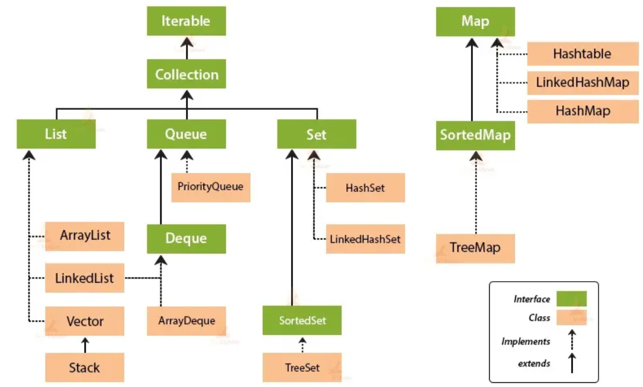

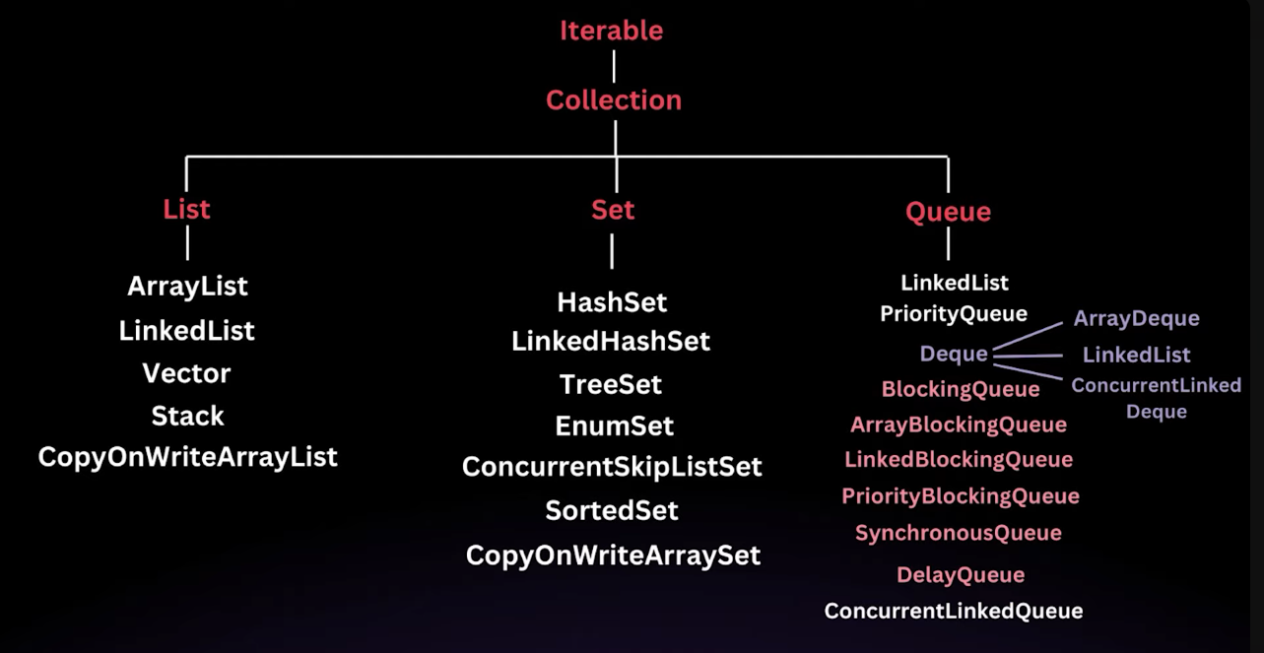

Enhanced For-each loop syntax works on arrays and anything that implements Iterable.

**.forEach()** method works on Iterable (e.g., ArrayList, Set, etc.) and **Streams**.

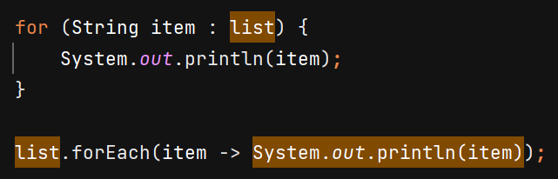



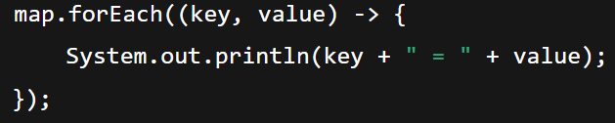

forEach() of Map takes BiConsumer which has key, value as arguments in it.

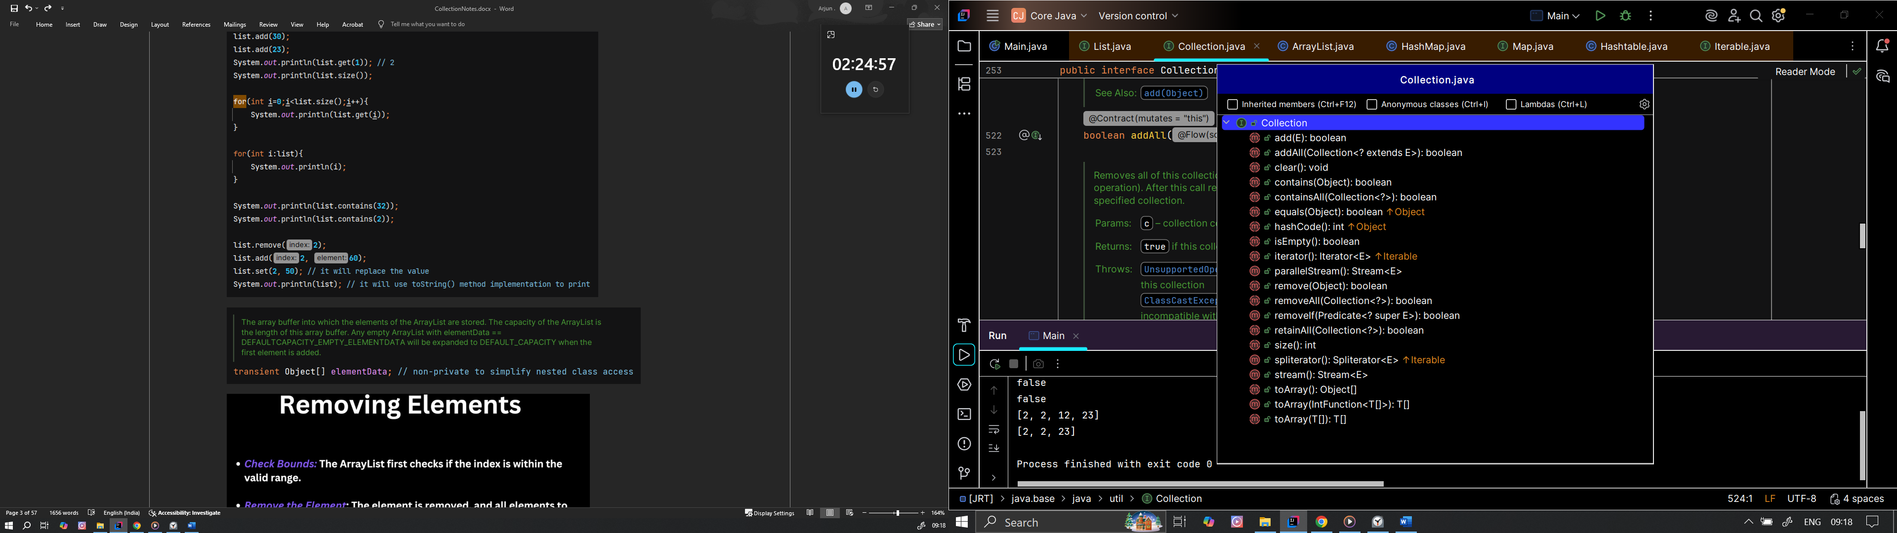 methods of Collection interface

**List Interface** 

**ArrayList**

* Resizable array, can change its size dynamically as elements are added or removed.
* It creates a new array when current internal array is full and copy the elements to new array.
* 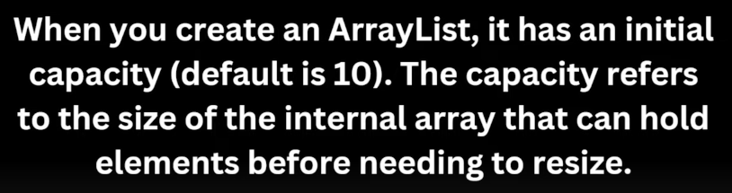
* 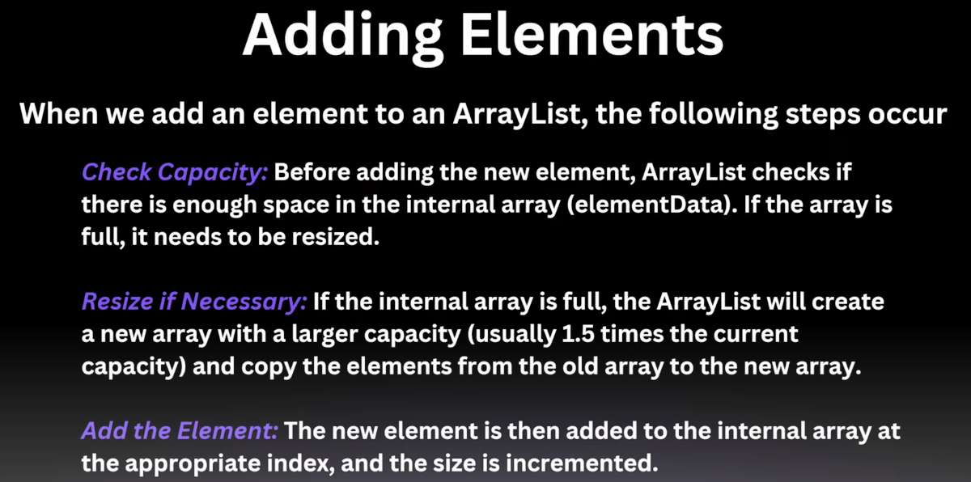

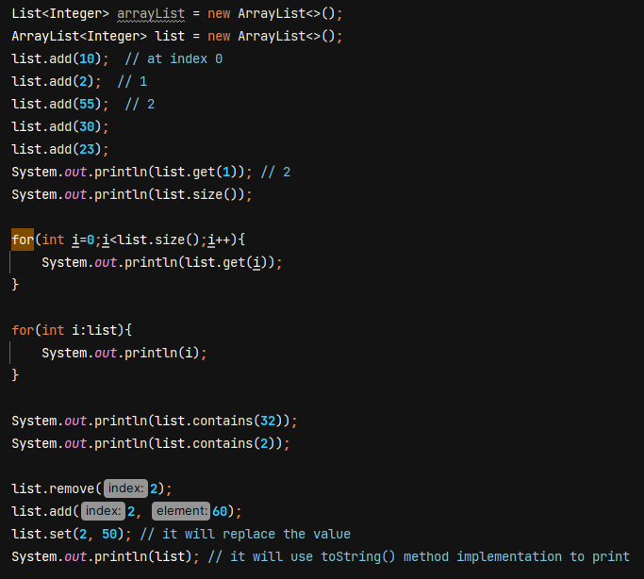

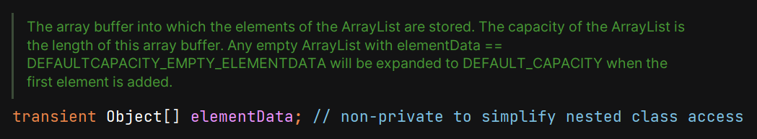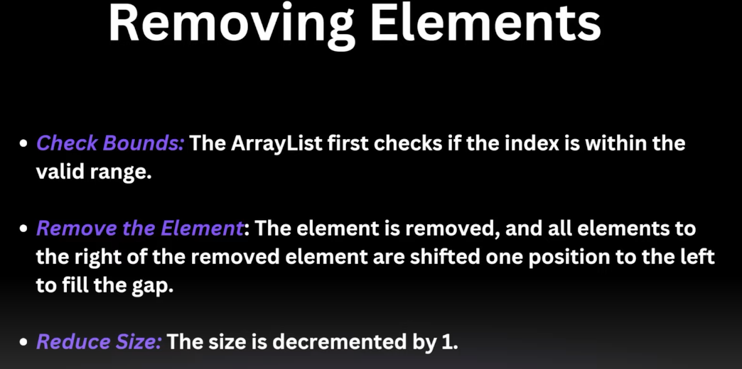

**Note :-**

To prevent the overhead of copying elements when creating new array on reaching capacity, if u know that ArrayList will have alteast n no of element then we can give initial capacity at initialisation.

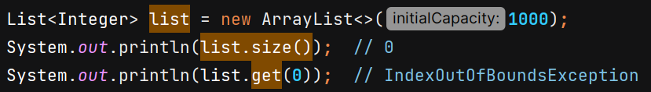

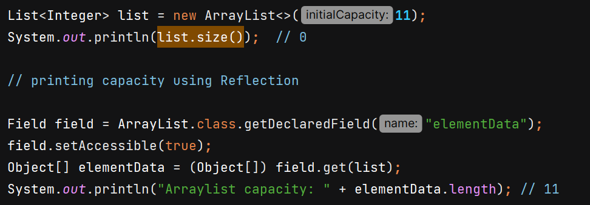

In ArrayList constructor we can give capacity or Collection.

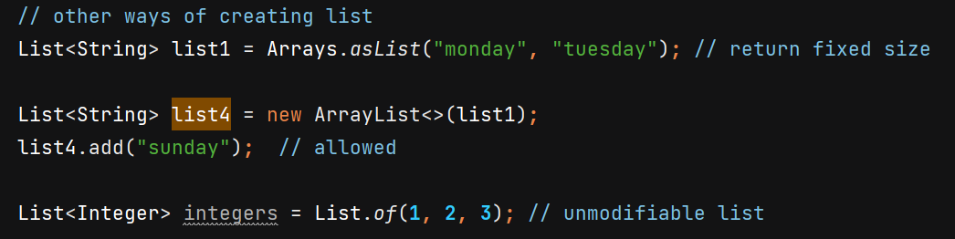

Note :- you cannot add, delete elements from list returned from Arrays.asList() and List.of(), both are immutable. For Arrays.asList() you can only call .set(index, value) method to modify it.

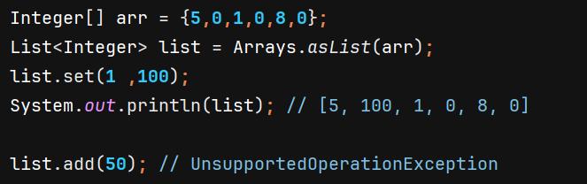

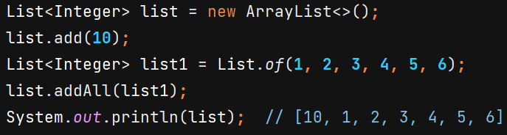

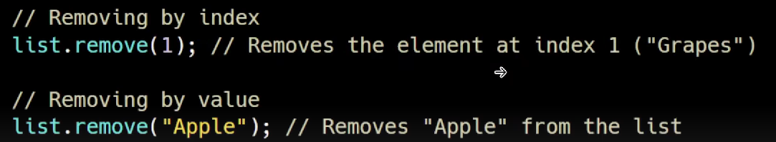

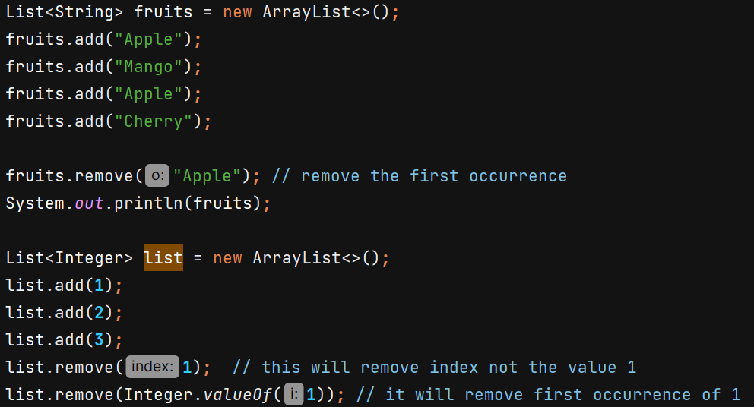



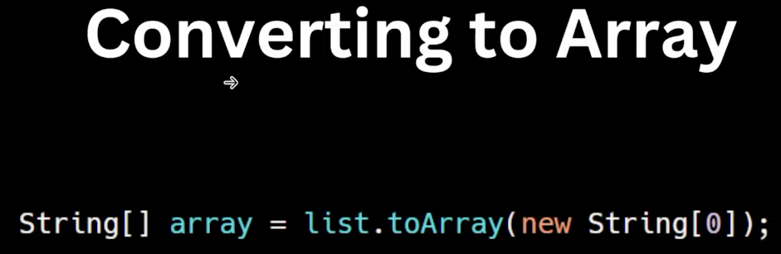 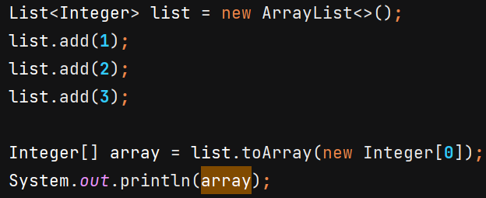

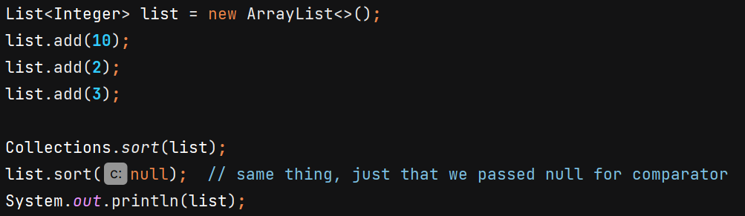

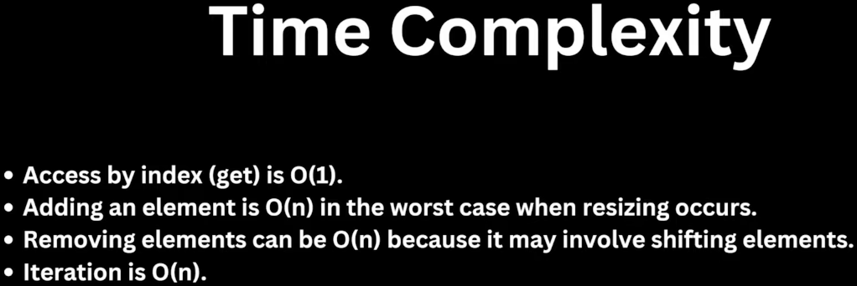

We can convert source Collection 🡪 destination Collection by passing it in constructor –

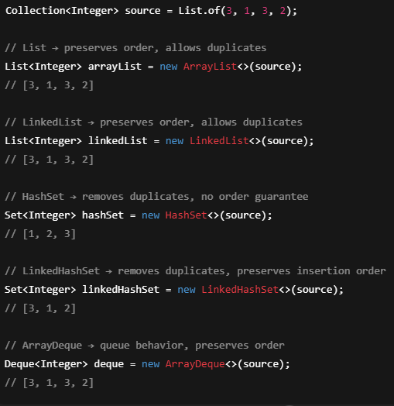

Note: 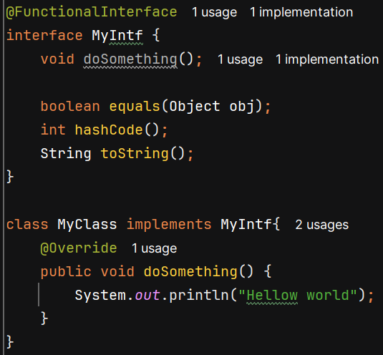

It’s still a functional interface with one SAM (only doSomething()), because equals, hashCode, toString are treated as inherited from Object, not as new abstract methods.

MyClass need not implement equals, hashCode, toString as it already inherits implementations from Object class and satisfy the interface’s declarations.

**Comparator** 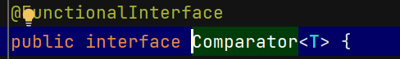

It is an interface using which we can do custom sorting.

It has which compares two objects of same type and determine their order.

The integer returned tells the relative order of two objects.

* If -ve then o1 comes first then o2
* 0 then o1 & o2 equal in ordering
* +ve then o2 comes first then o1

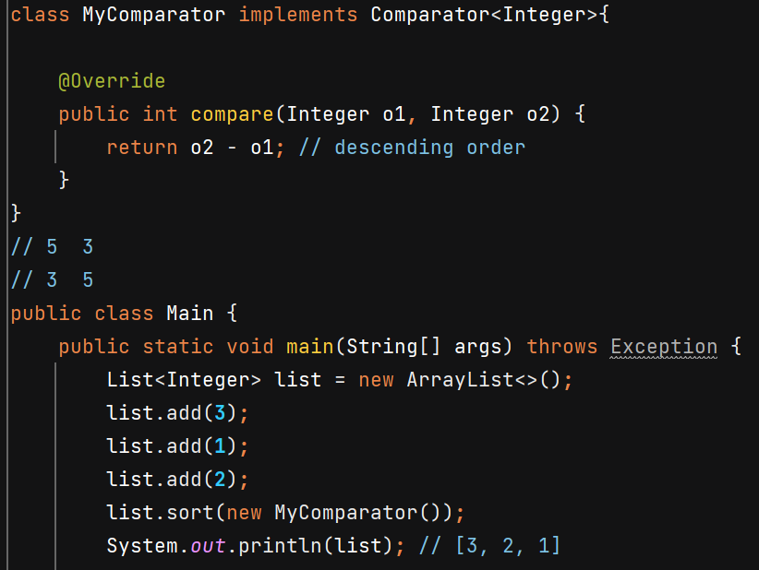

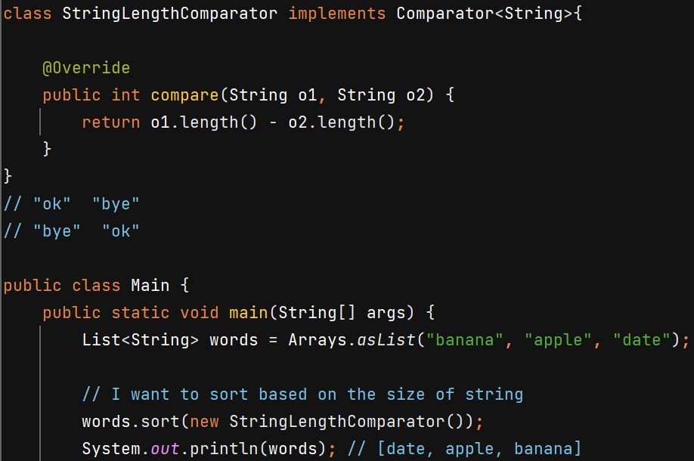

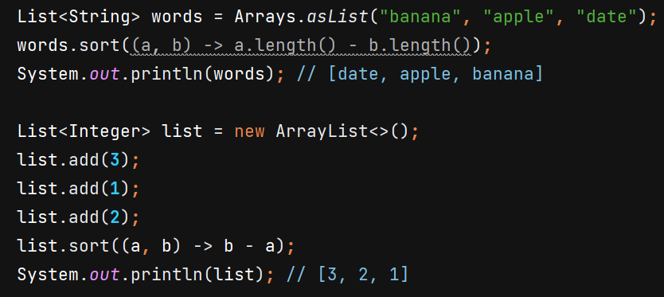

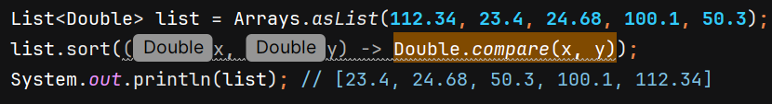 similarly we have compare(x,y) method in Float, Long, Integer class also.

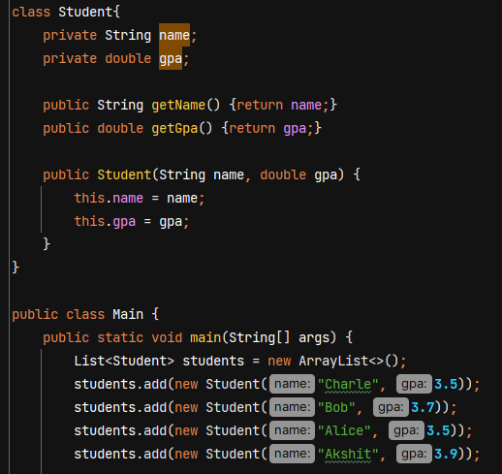

If we try to do **students.sort(null)** then we’ll get Exception as we don’t provide the Comparator and java doesn’t know the natural ordering for Student class untill unless we implement the Comparable interface.

Ex- for String instances, Java knows the natural ordering as String class implements Comparable<String> interface and provide implementation for compareTo(String anotherString) method.

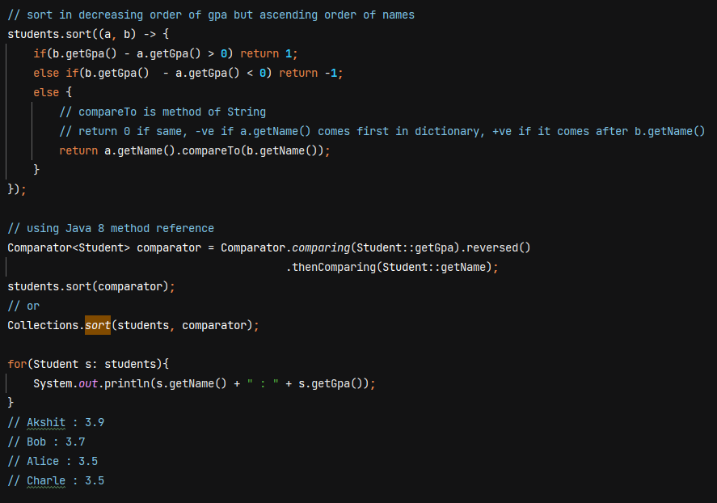

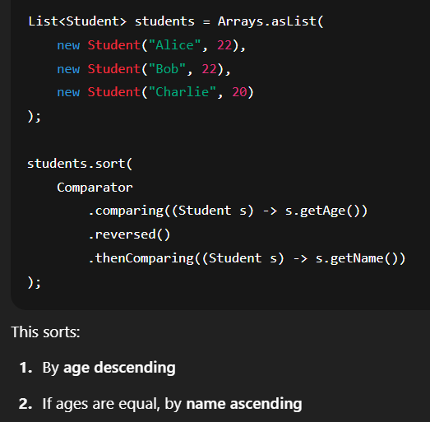 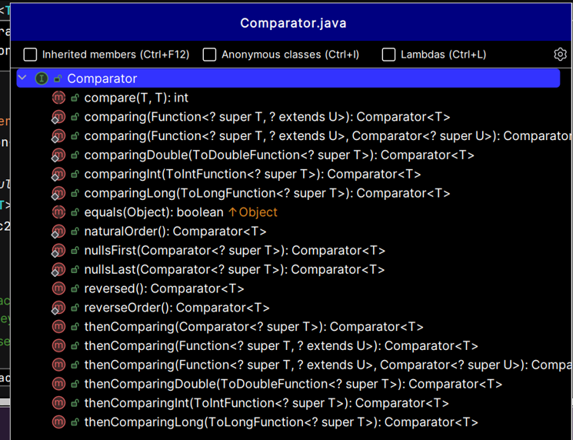

Sort List of String in reverse lexicographically order –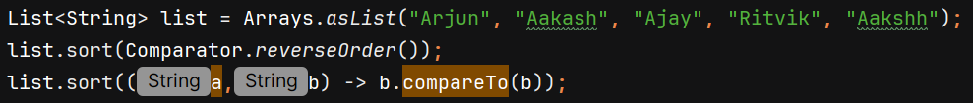

**LinkedList**  🡪 stores its elements as nodes in a doubly linked list

Custom implementation will be like –

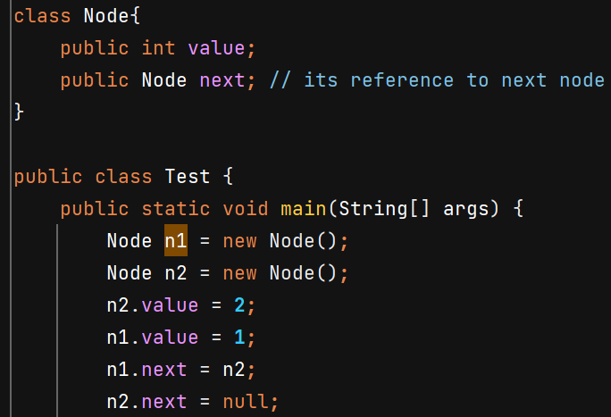 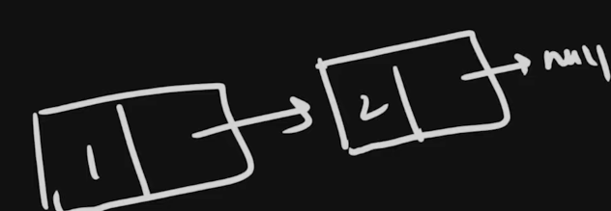

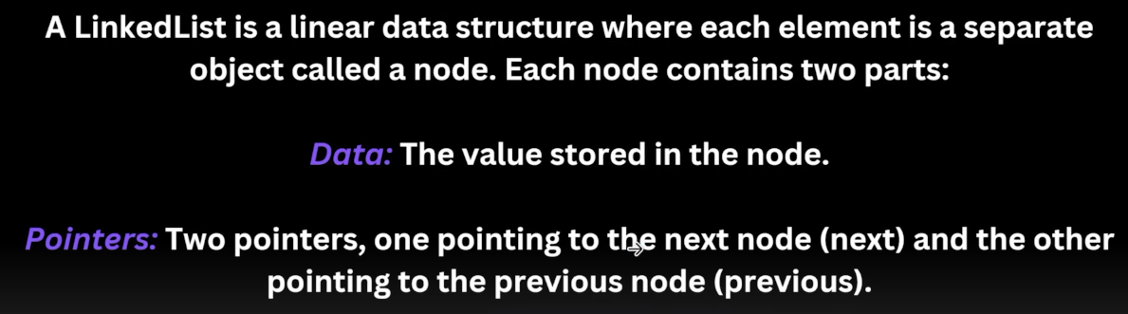

We can’t directly access the elements with .get(i) in O(1) instead we have to run loop so **time complexity of get(i) is O(n)**

LinkedList uses more memory due to extra references (previous and next nodes).

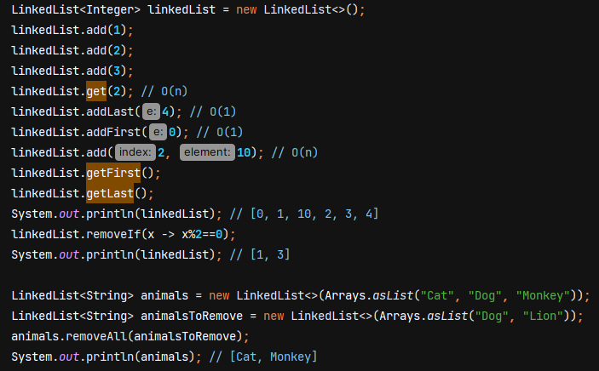

We can also write reference as List, but then we won’t be able to access the method which aren’t part of List interface likd addLast() and addFirst()

**Vector**

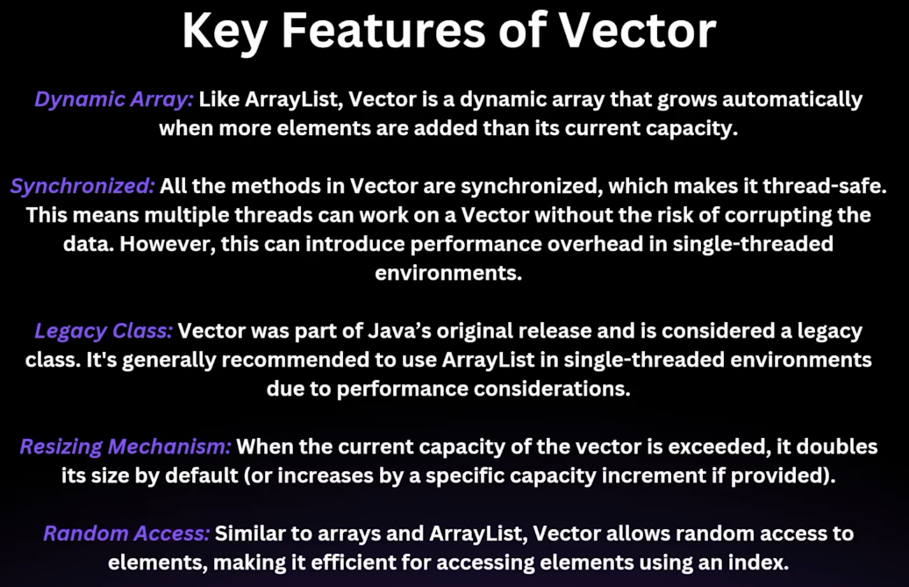

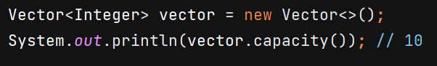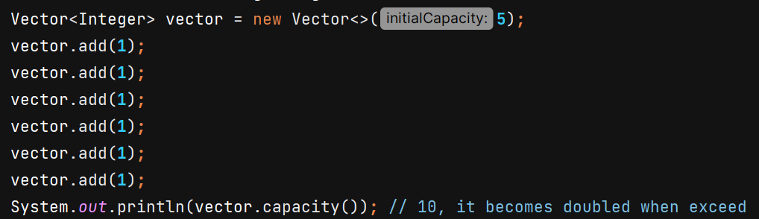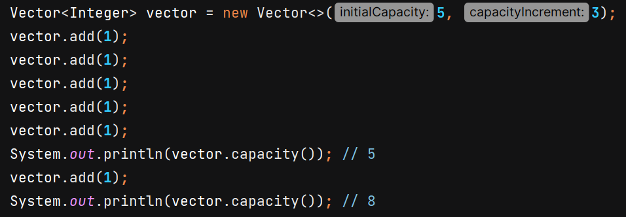

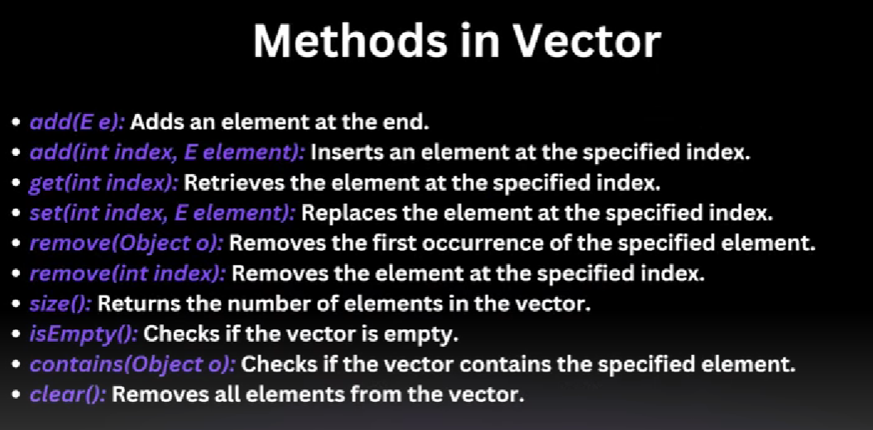

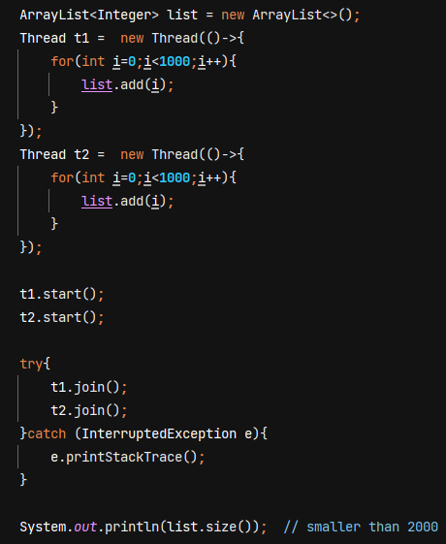 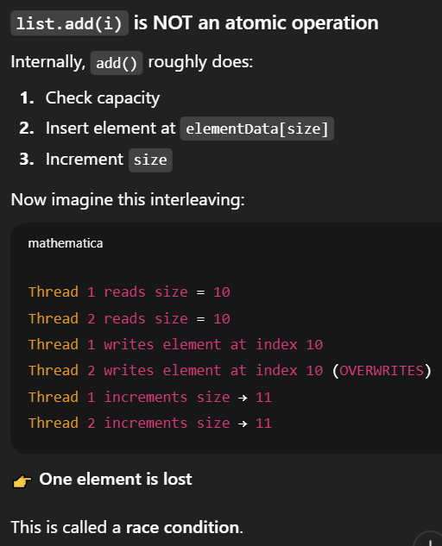

Threadsafe – at same instant only 1 thread can access the list and add

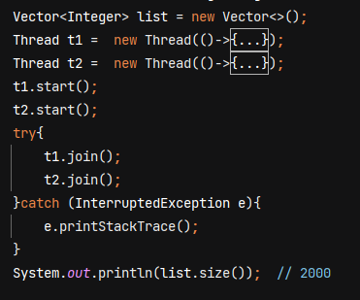

**Stack**



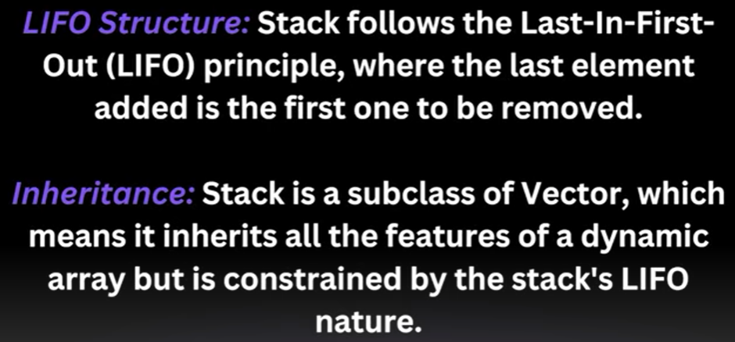

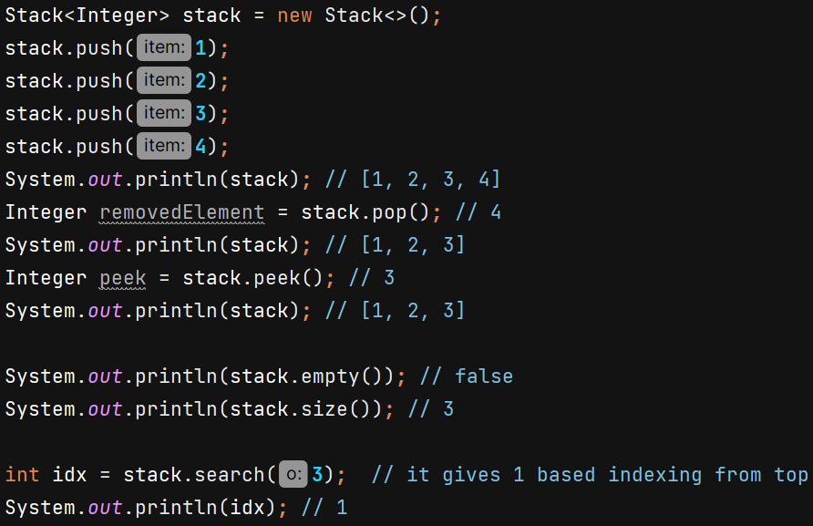

**LinkedList as Stack** 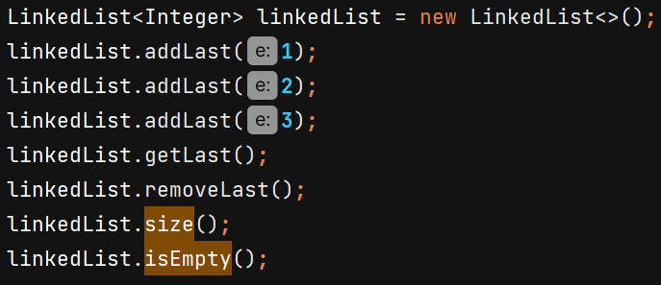

In single threaded environment we can use LinkedList as stack to avoid synchronization overheads.

**ArrayList as Stack** 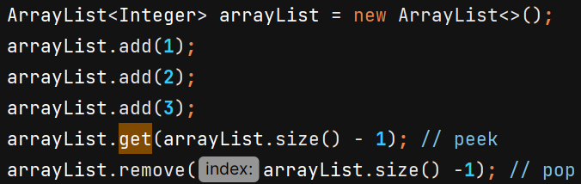

**CopyOnWriteArrayList**

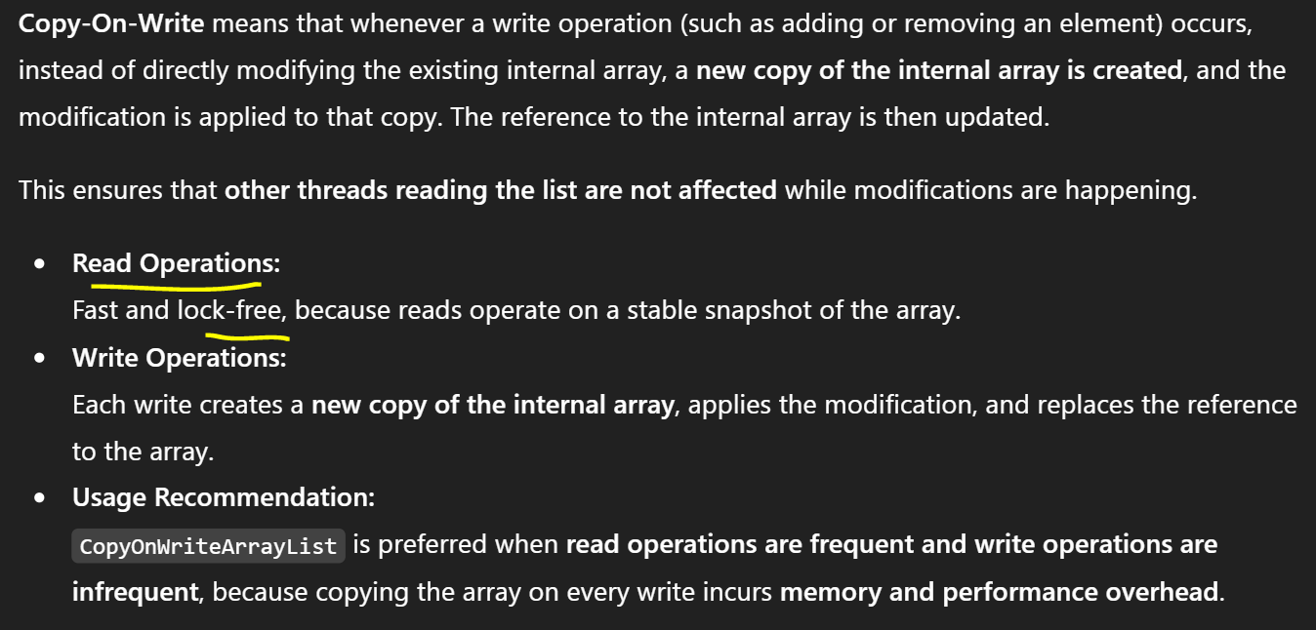

It is thread safe. All Write operations use **synchronized** block on a private **Object** named **lock** (Java 11+). 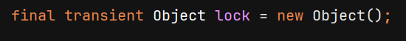

Java 8 and earlier used **ReentrantLock** for all write operations.

ArrayList should not get modified while reading -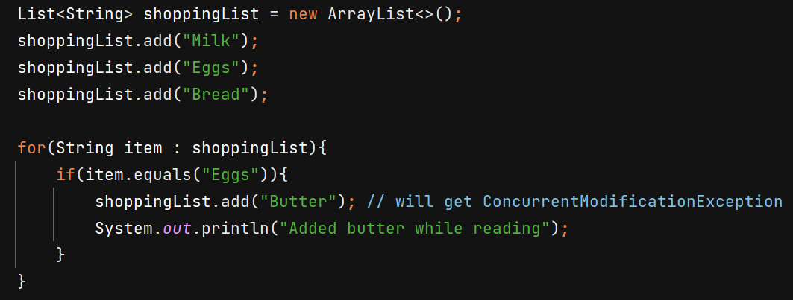

Works fine now -

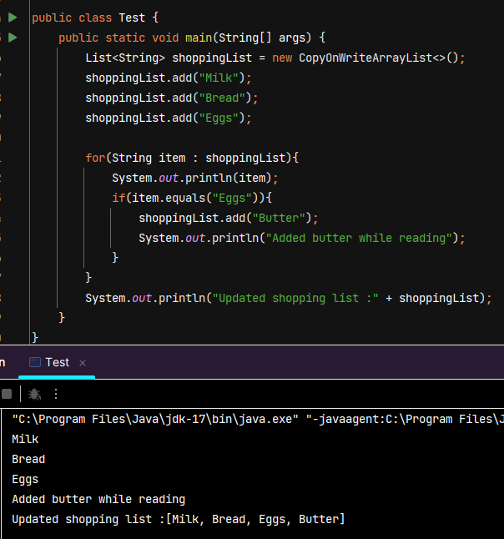

Reading and modifying happening at same time. Its possible because read happened on original snapshot but write happened on separate copy. Loop will only run on original list. When read is complete then internal array of shoppingList reference variable will start pointing to new copy array.

Another example to demonstrate –

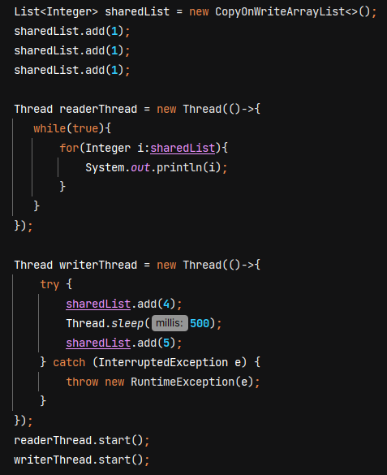

**Map**

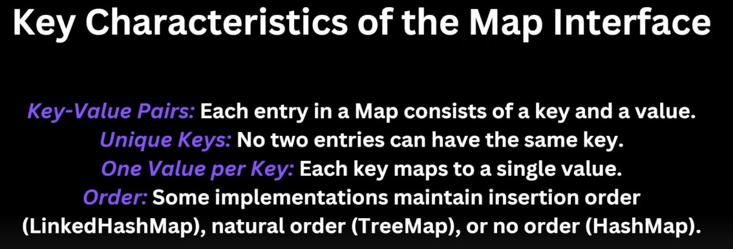

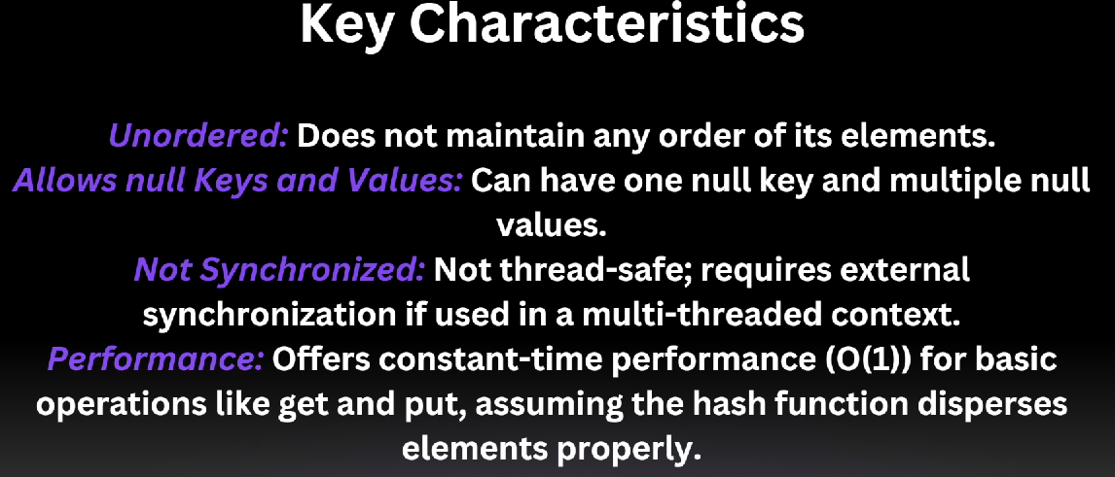

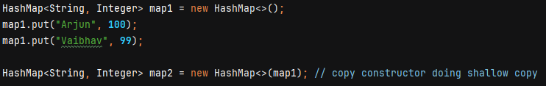

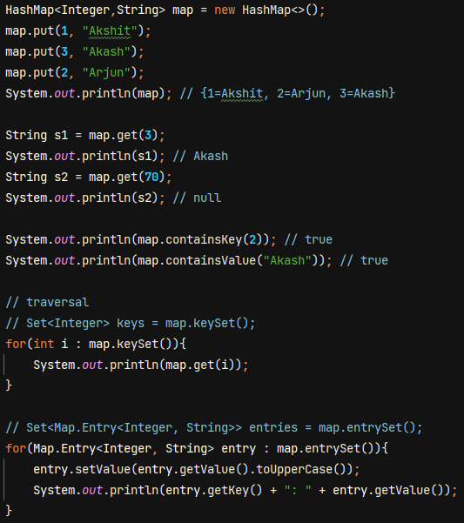 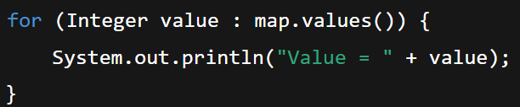

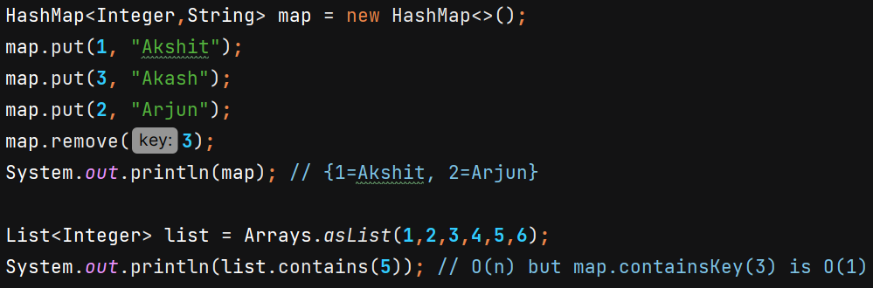

**Internal Working of Hashmap**

Steps for storing data in Hashmap –

1. Hashing the key using hash function to get hashcode. Hash function should be deterministic (same input will always produce the same output) and spread the keys uniformly in bucket array.
2. Calculating the index in bucket array where key-value pair will reside using compression function (index = hashCode % arraySize)
3. Storing the key-value pair in the bucket at the calculated index. Each bucket can hold multiple key-value pairs.

Hash function can give same output for different inputs leading to collision.

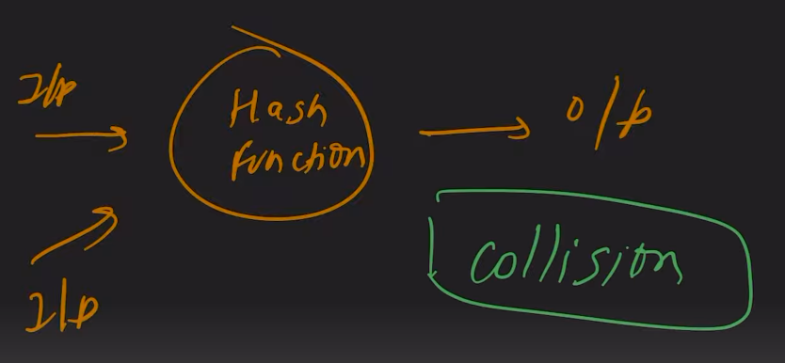 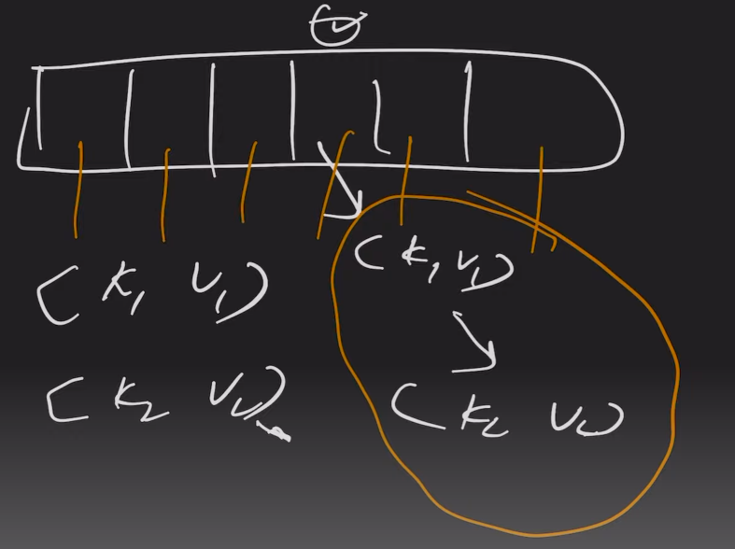

We do collision handling using separate chaining with linkedList. Each buckey of array stores head of LinkedList.

In worst case time complexity is O(n) as searching in LinkedList is linear.

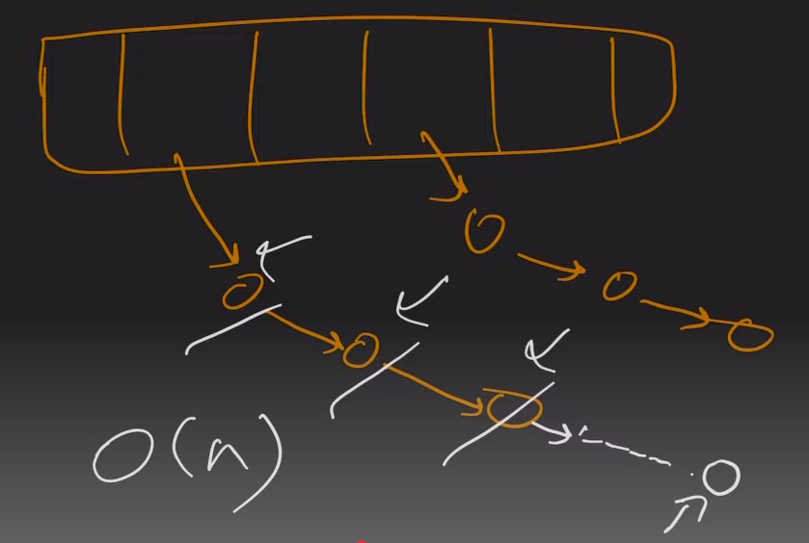 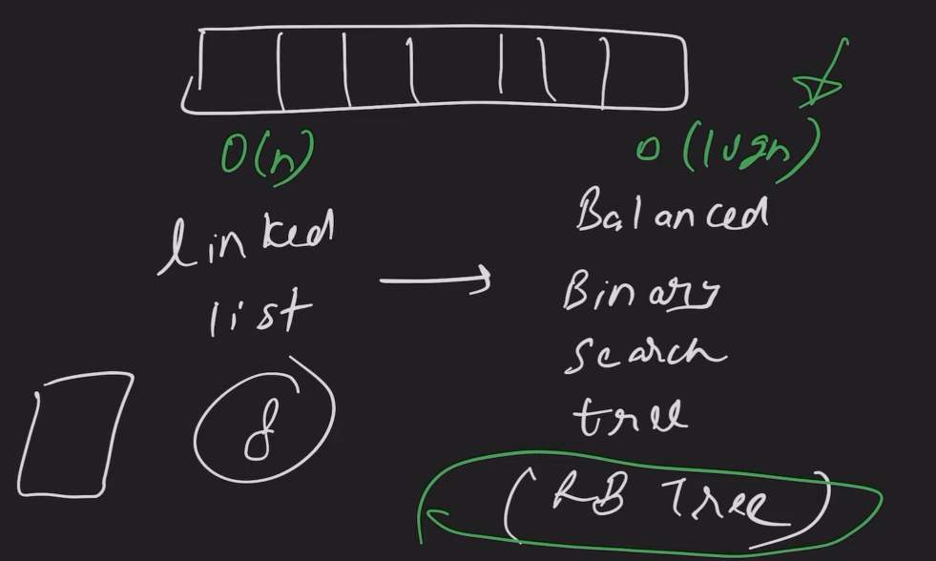

**After Java 8**: When the linked list size crosses a certain threshhold, it is converted to Balanced Binary Search Tree (Red Black Tree) to reduce time complexity to O(Log n).

For HashMap TREEIFY_THRESHOLD = 8

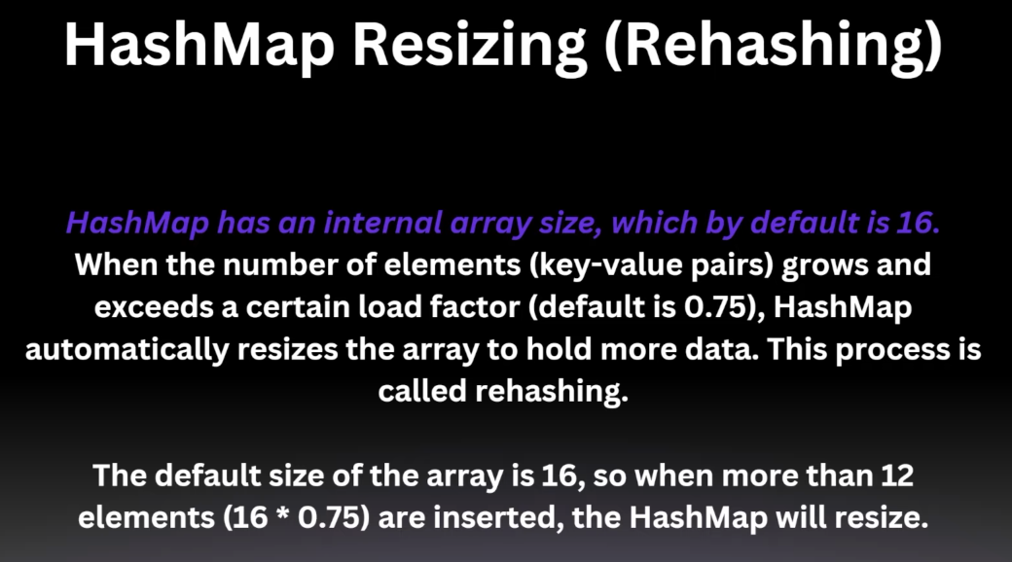

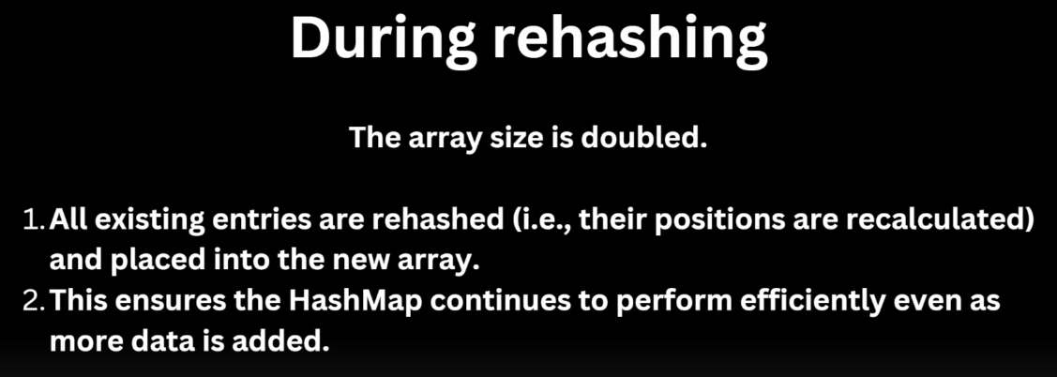



Ex 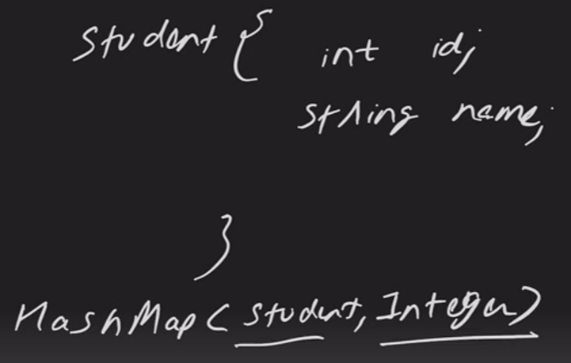 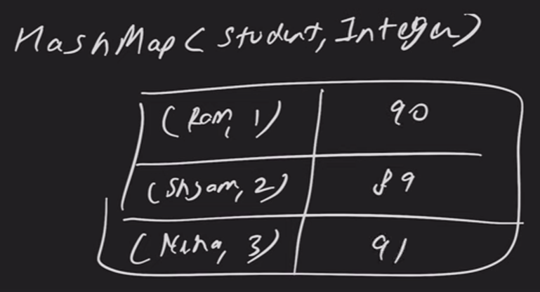

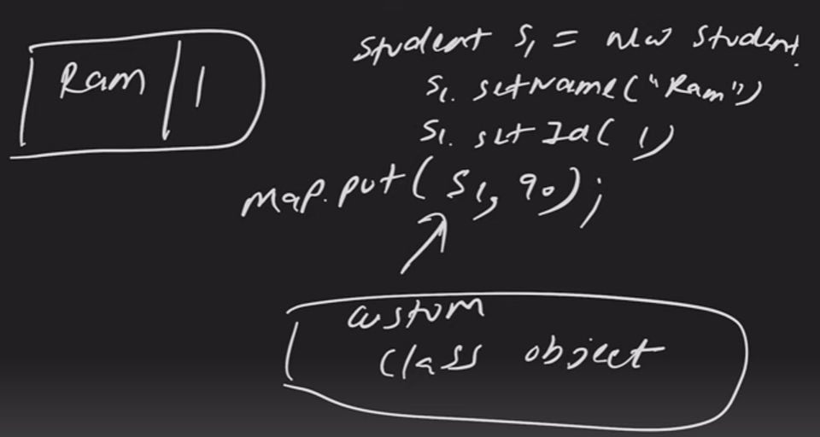

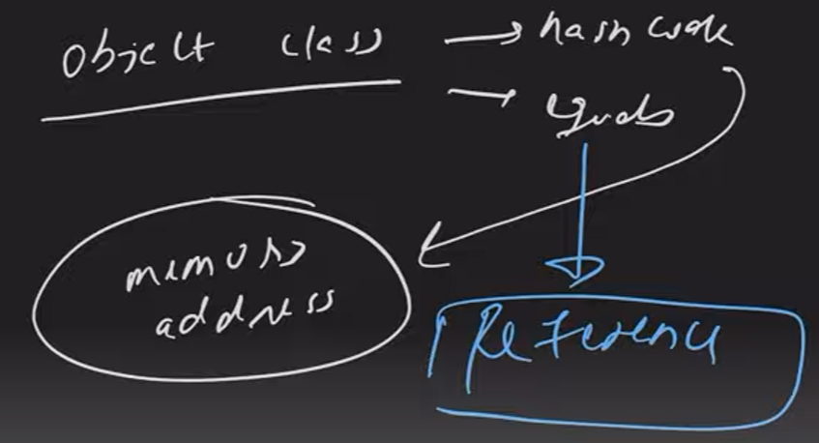

Every instance of Student class will have different hashcode based on memory address.

The default implementation of equals() in Object checks for **reference equality**, which means it compares the memory addresses of the two objects.

Ex - The String class overrides the equals method to compare the **content** of the strings rather than their memory addresses.

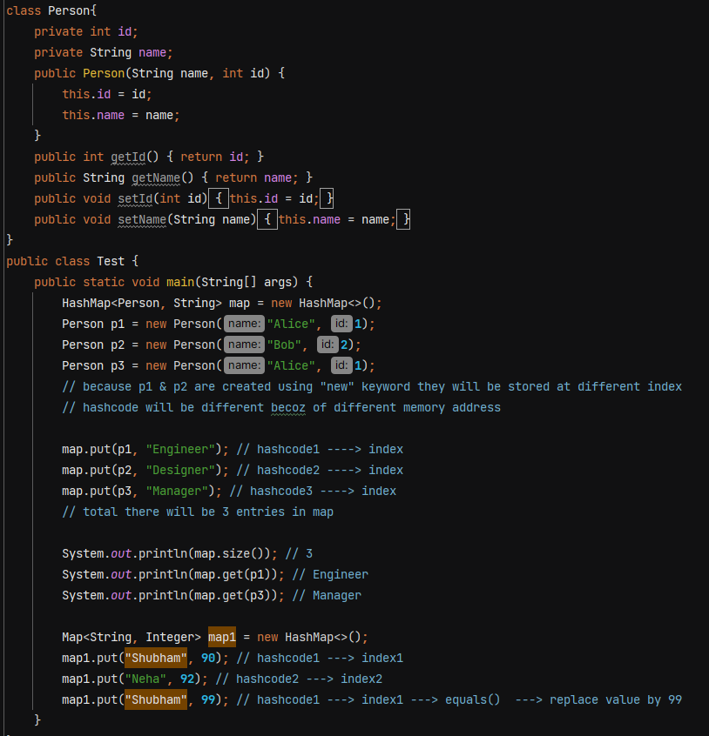

We want to make it understand that p1 & p3 both are same and their hashcode generated should be same. To do that **we have to override hashcode() and equals() method**. We also override these methods when storing custom class objects in Set.

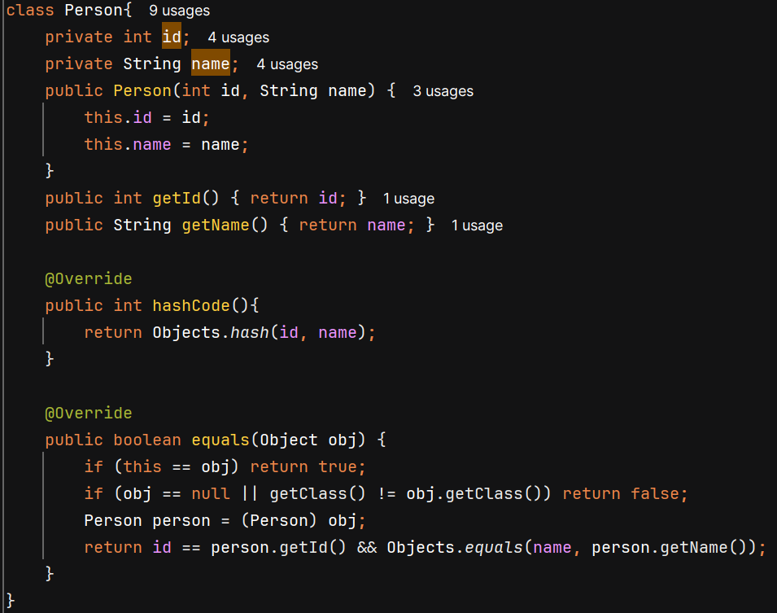

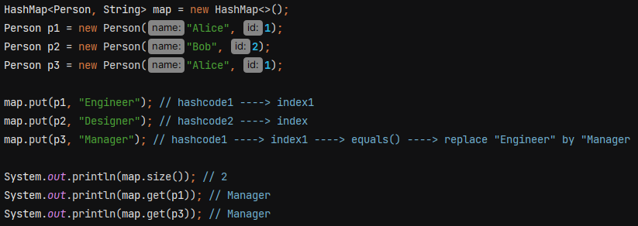

**Time Complexity –**

Put(k, v), get(k), remove(k), containsKey(k) 🡪 O(1) avergae, O(log n) worst case

containsValue(v) 🡪 O(n)

**LinkedHashmap** – order gets maintained, it is not threadsafe just like HashMap

LinkedHashmap has a double linked list that store all the entries inside it in the order in which you inserted. It is slower and takes more memory in comparison to hashmap.

Its constructor can take three values – initialCapacity, loadFactor and accessOrder

**accessOrder is by default false. (which means storing as per insertion order, true for storing as per access order)**



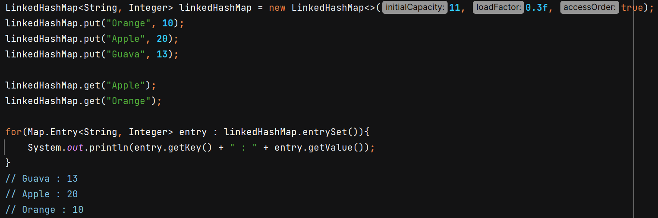

When accessOrder is true, it gives behaviour of LRU cache. Least recently used item is on starting and latest used item on end. So, we can remove the LRU items from top.

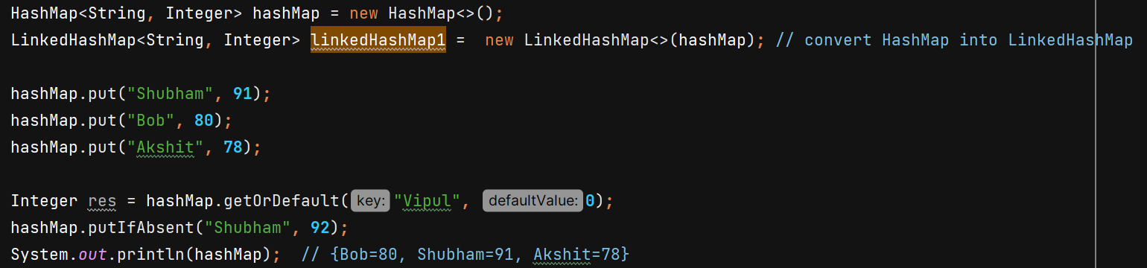

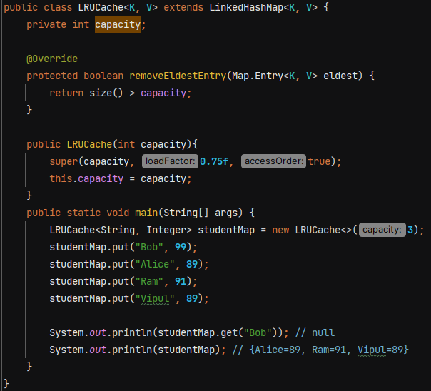

**WeakHashMap**

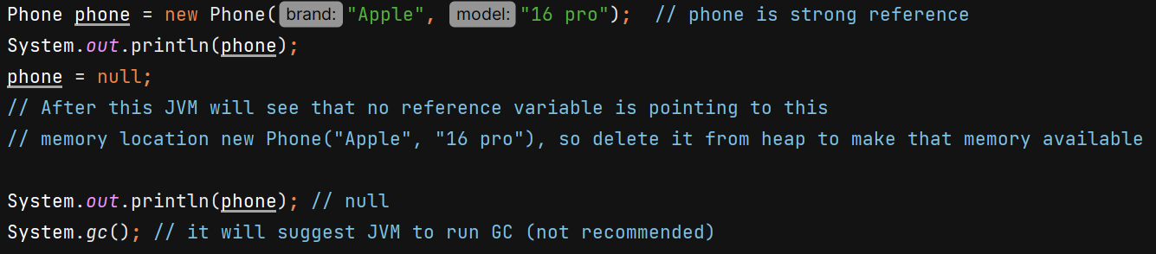

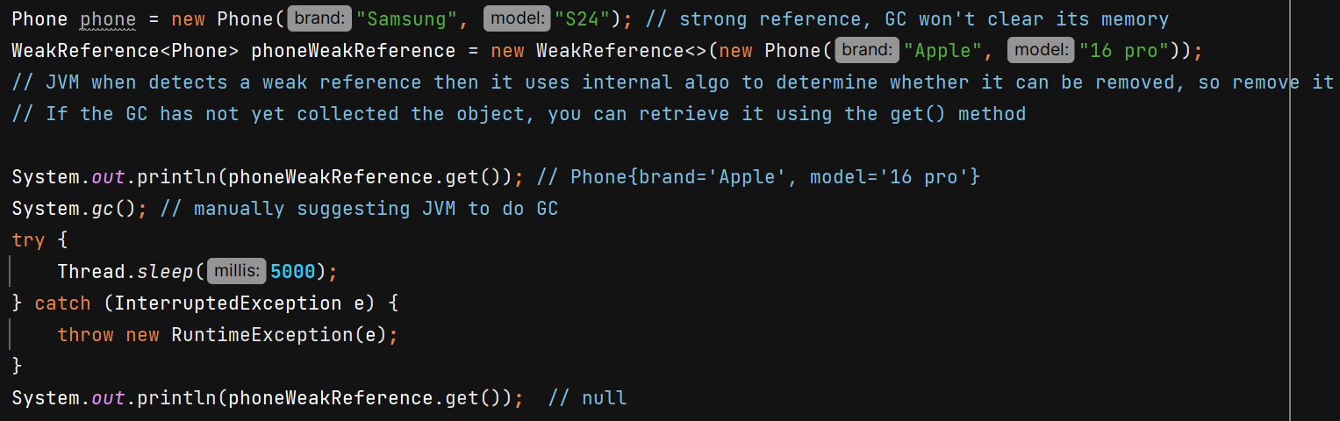

An entry in a WeakHashMap will automatically be removed when its key is no longer in ordinary use.

Example with non literal string –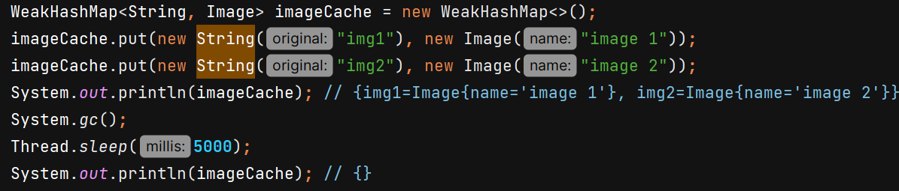

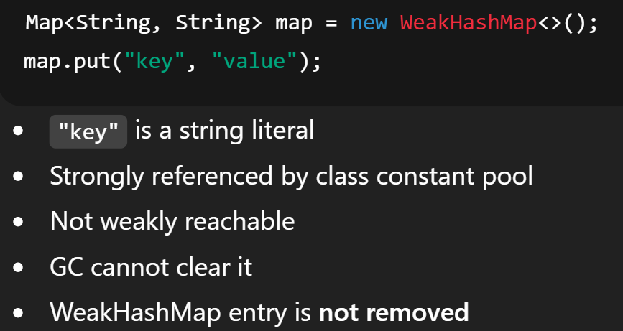 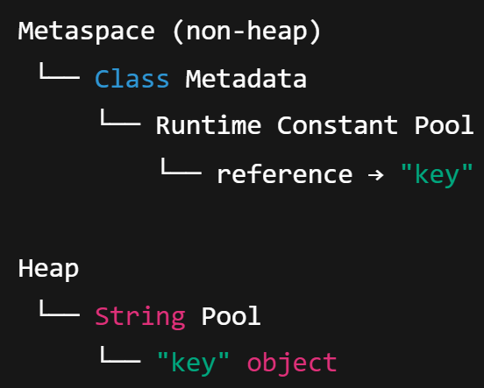

**Class Constant Pool** is a **runtime data structure created by the JVM for each loaded class**.

String literals are not garbage collected as long as the class remains loaded.

**IdentityHashMap**

equals method of the String class in Java is overridden to compare **the content** (logical equality) of two strings rather than their memory addresses.

The overridden hashCode method in the String class computes the hash code based on the content of the string, rather than its memory address.

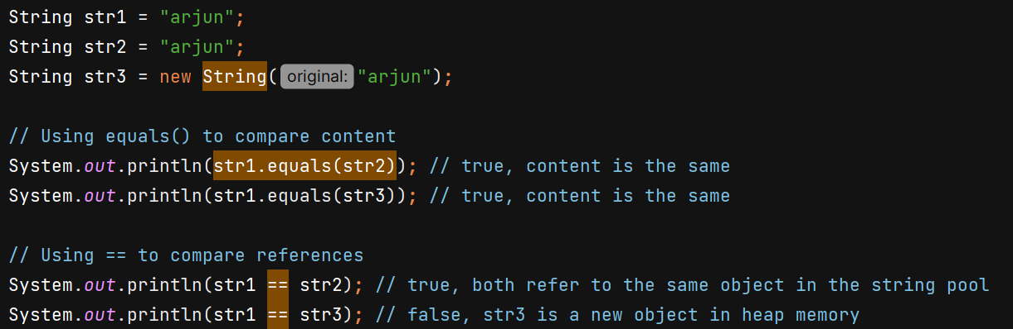

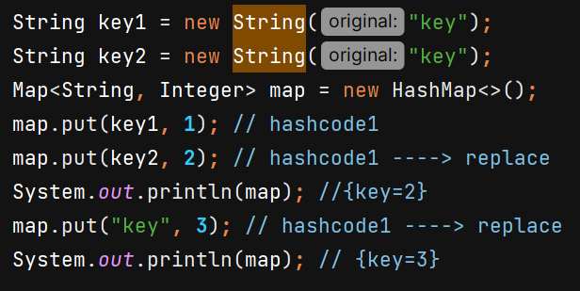

Whether in ur class u override the hashcode or not**. IdentityHashMap uses the hashcode() method of Object class to generate hashcode based on memory address**. And it won’t use equals() method to compare but **it uses == operator which will check memory address**

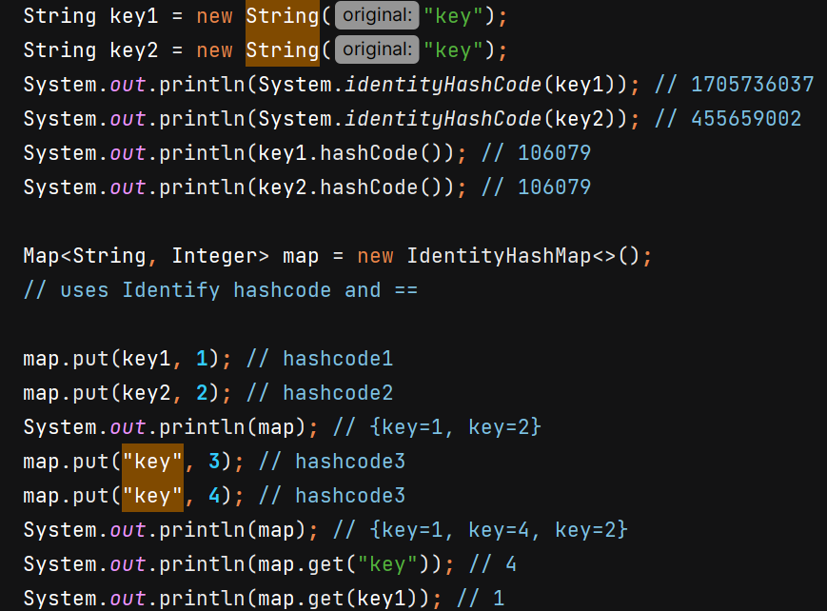

**Comparable** – allows a class to define its natural sorting order

Comparator is used when we need to sort using some custom logic.

list.sort(null) means we want natural ordering. For that class needs to implement Comparable<T> interface and implements compareTo() method and write sorting logic inside it. U can sort only based on 1 criteria.

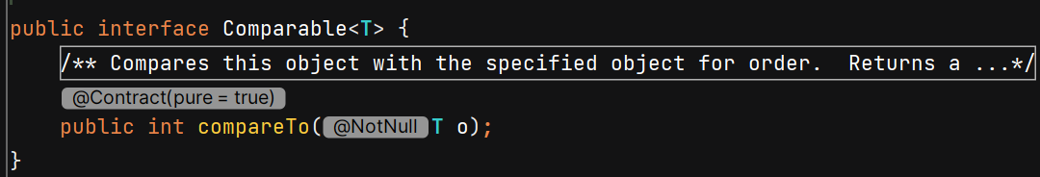

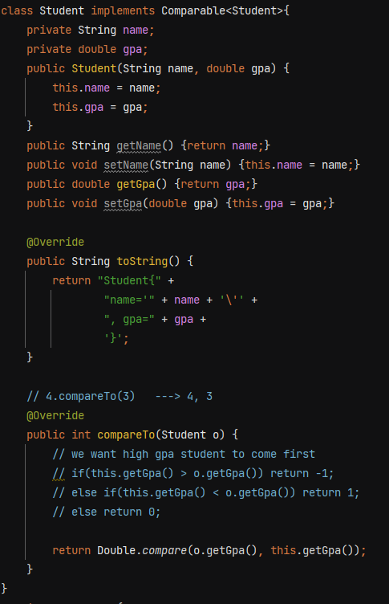

Similarly, we have Long.compare(), Float.compare()

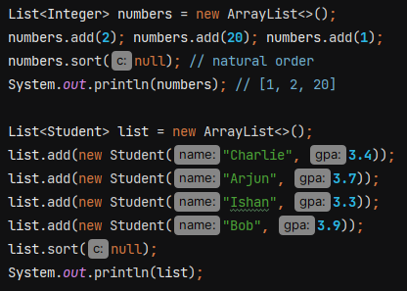 O/P – descending order of gpa

**SortedMap** – it’s an interface and TreeMap is its implementation



Null key is not allowed as sorting can’t happen, it will throw NPE

**TreeMap internal implementation is Red Black tree** which is self balancing binary search tree.

Time complexity = O(logn)

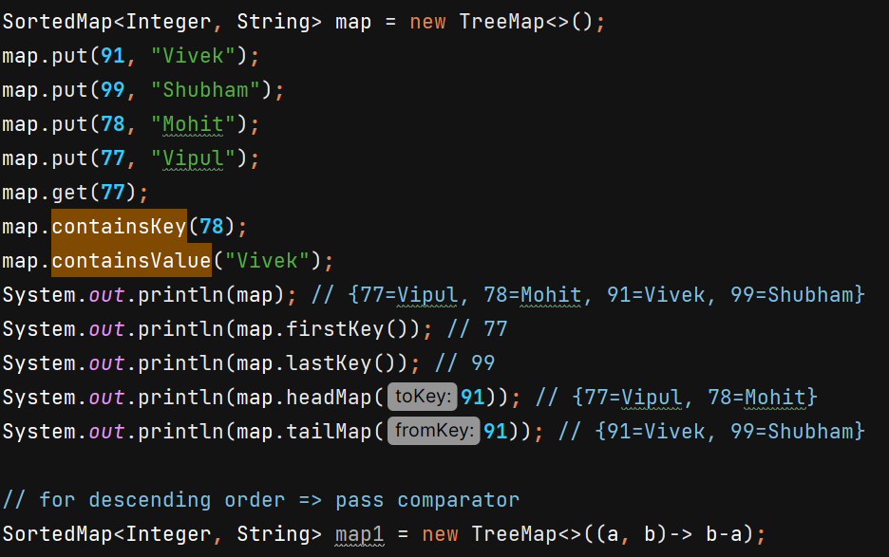



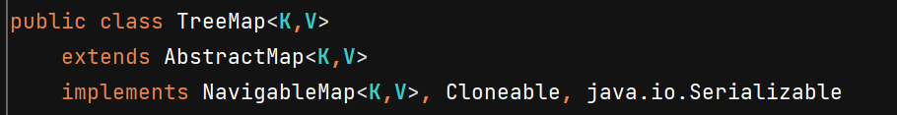



**Hashtable**

* All methods are synchronized (get, put, etc) that means Lock is on the entire map object
* No null key or value
* **Replaced by ConcurrentHashMap**
* Slower than HashMap as only 1 thread can access the map at a time.
* Implements Map
* Only LinkedList used in case of collision no RBT

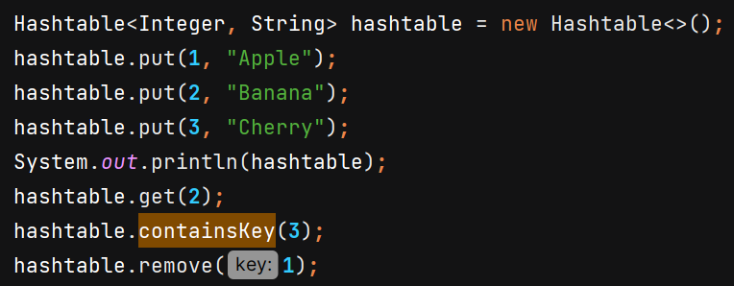

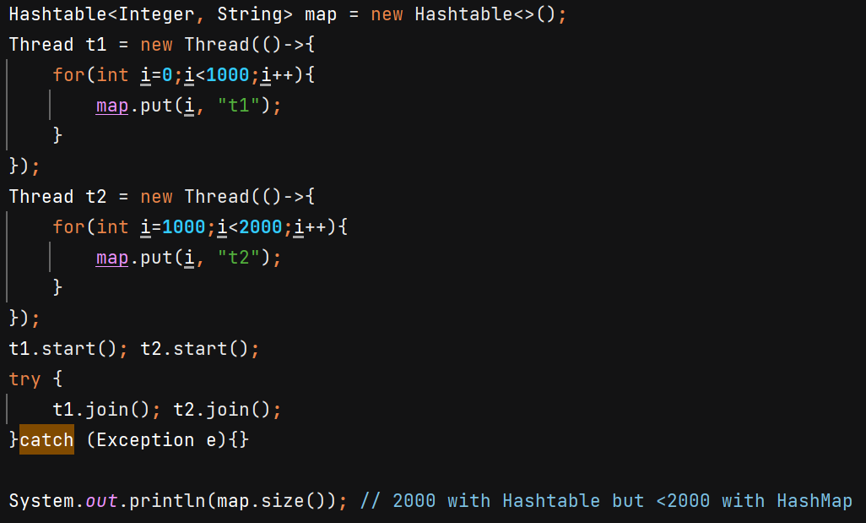





**ConcurrentHashMap** –

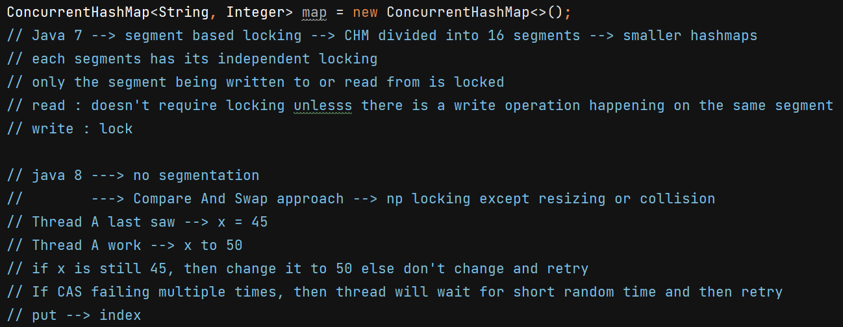

* Goal: **Allow multiple threads to read & write concurrently with minimal locking**
* It is thread-safe because it uses lock-free reads, CAS operations, and fine-grained bucket-level locking instead of a global lock.
* Faster than HashTable and Collections.synchronizedMap()
* Does **not allow null** keys or values

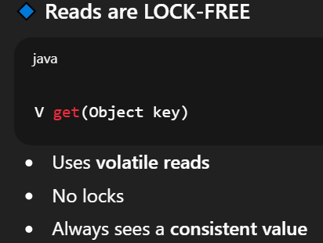 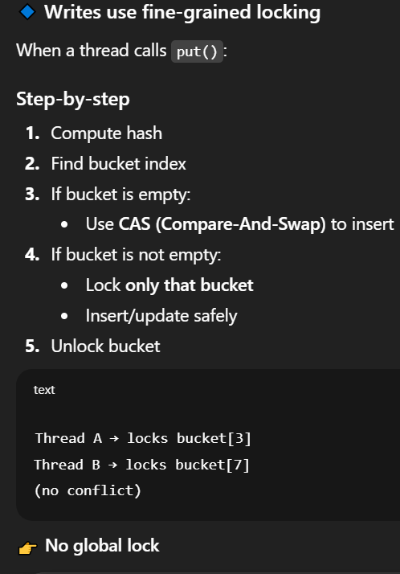

Till Java 7: the map was divided into an of 16 segments. When a thread wanted to write, it only locked **one segment**, not the whole map. This meant up to 16 threads could write to different segments at the exact same time.

But since Java 8: the lock granularity is now at the bucket level. If you have 1024 buckets, you could theoretically have 1024 threads writing simultaneously if they all hit different buckets.

**ImmutableMap** – cannot change the content once instantiated

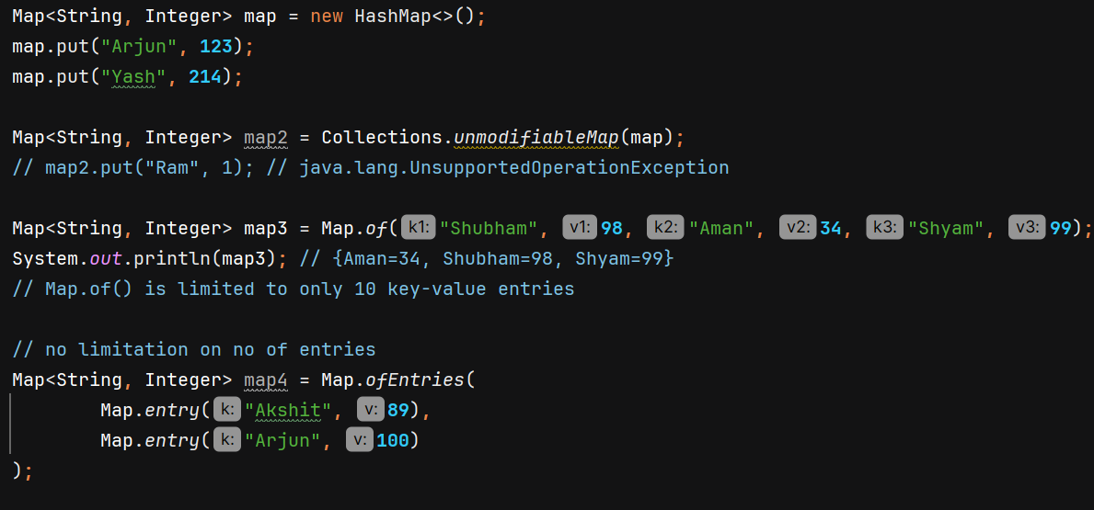

**EnumMap** –

* directly implements map interface
* knows all possible keys in advance is more efficient compared to HashMap
* No hashing needed, values directly mapped to ordinal index
* Maintains order of the enum constants ordinal values

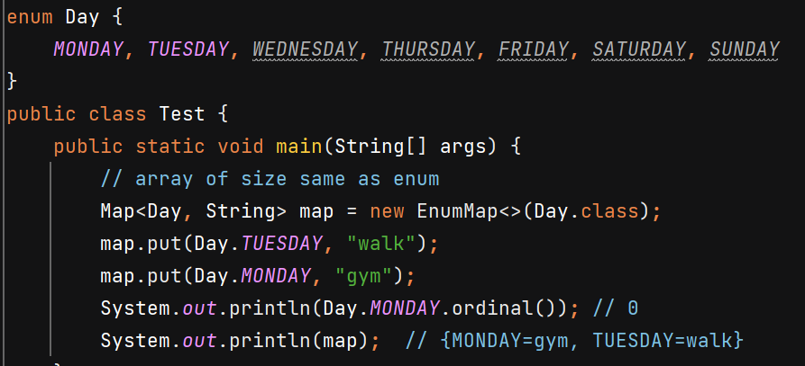

**ConcurrentSkipListMap** –

* thread safe and sorted in order of its keys. TC = O(Log n)
* data entry stored in skiplist data structure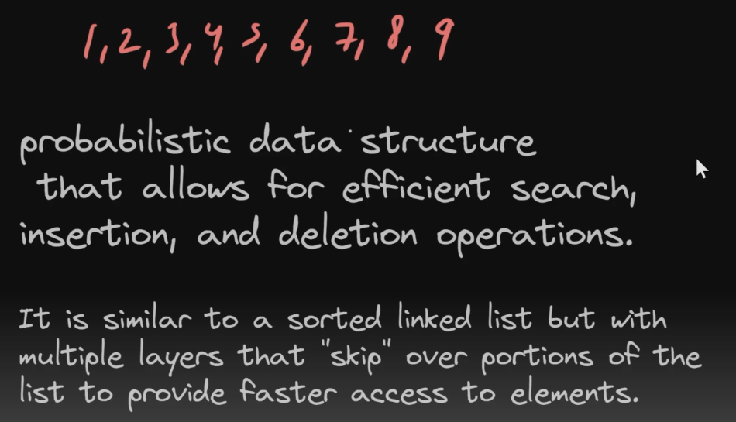no overhead of balancing RB tree 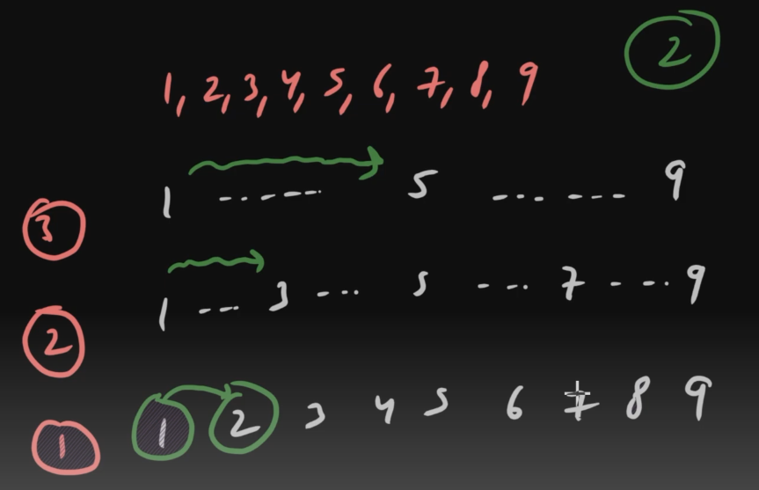

On topmost level many elements are skipped, on 2nd level lesser elements are skipped and at the last level no element is skipped.

Suppose we want to search 2, then start from topmost level left side. Move right if next.value <= target. If > target, then move to 1 level down at same position and do the same.







**Iterator** – used to traverse over the Collection

we are able to use enhanced-for loop on ArrayList because it implements Iterable interface and provides implementation of iterator().

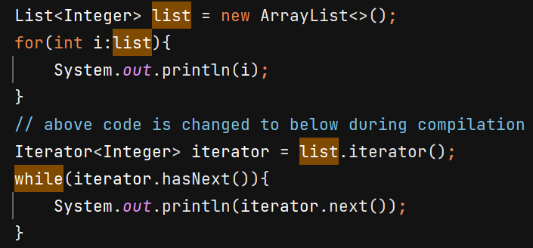

Iterator provides functionality of removing while iterating – but it only work when remove() is called after next() and only once.

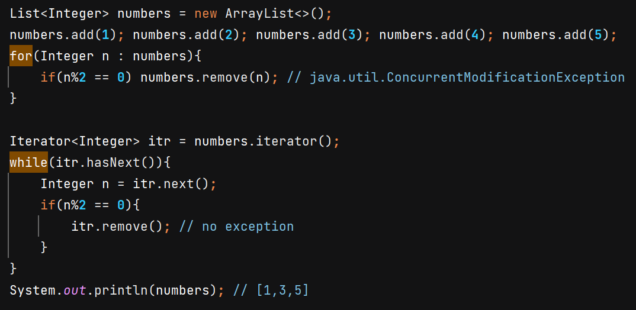

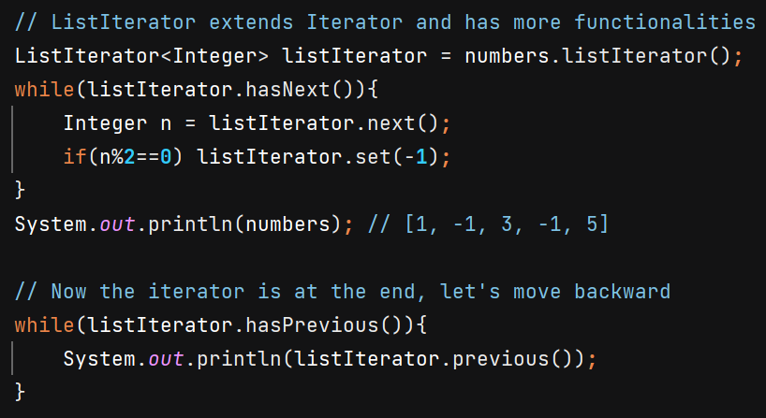

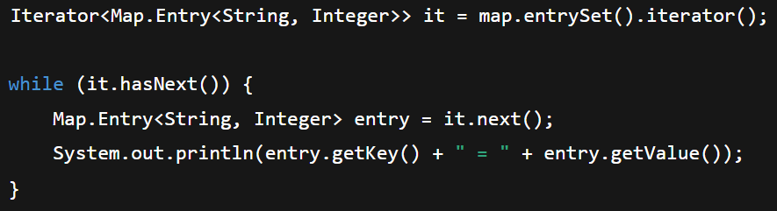

**Sets**



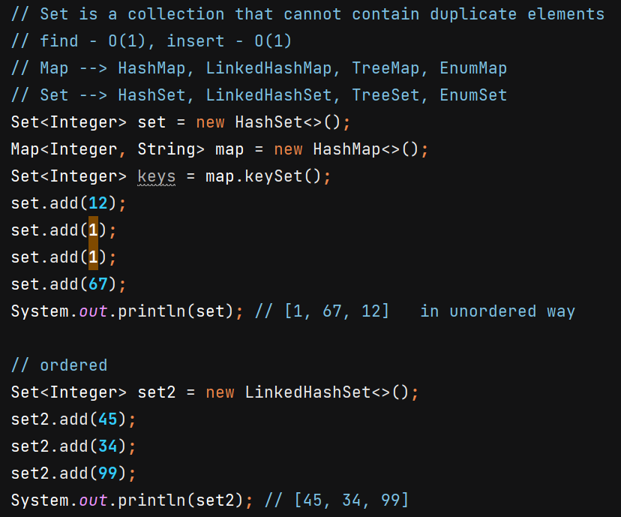

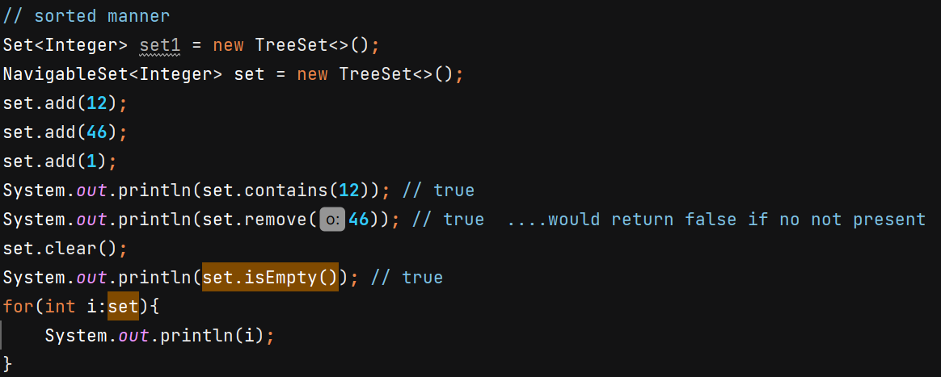

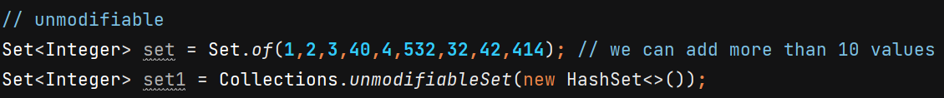

**Collections.synchronizedSet()** wraps the underlying set (e.g., HashSet) and synchronizes **every method** on the set using a **single lock**. Even **read operations** (like contains() and size()) are locked. Although reads generally don’t modify the set, they still have to acquire the lock.

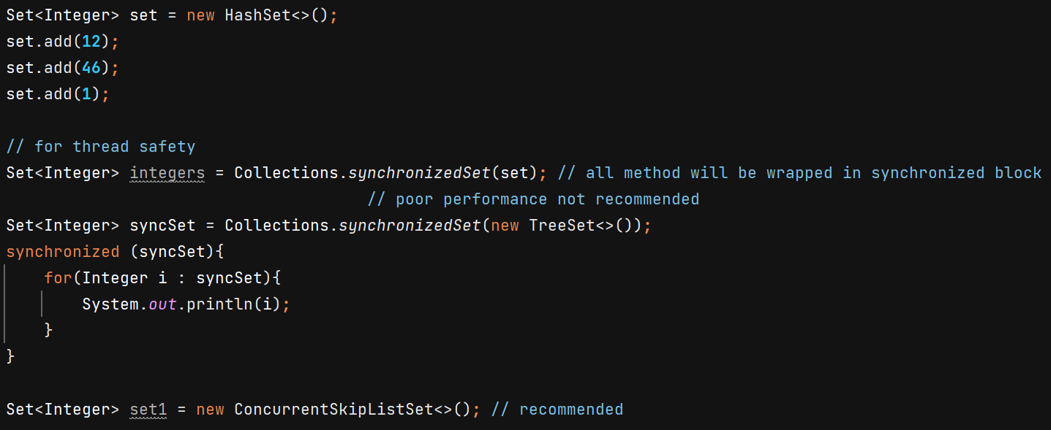

In ConcurrentSkipListSet, data is stored in sorted manner, useful in frequent reads & writes. It is thread safe. Implementation is based to ConcurrentSkipListMap. TC = O(Log n)

**CopyOnWriteArraySet –**

* Thread safe, No Sorted
* Copy-On-Write mechanism –

**Reads** happen on a shared, immutable snapshot of internal array (**no locking**)

**Writes** create a **new copy** of the data, modify it, and then **atomically replace** the old reference

* Uses synchronized block on lock Object for write operations 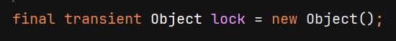
* useful when read operations are frequent
* Iterators Do Not Reflect Modifications – The iterator captures a **snapshot of the internal array at that moment.** That snapshot **never changes.**

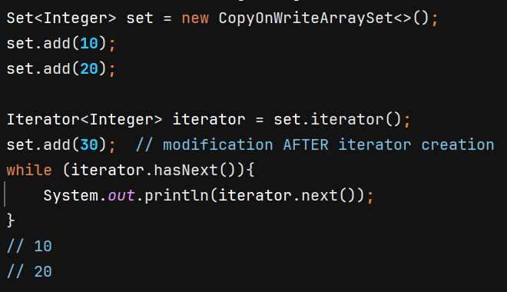In HashSet, we get ConcurrentModificationException on iterator.next() because the element was added after set.iterator()

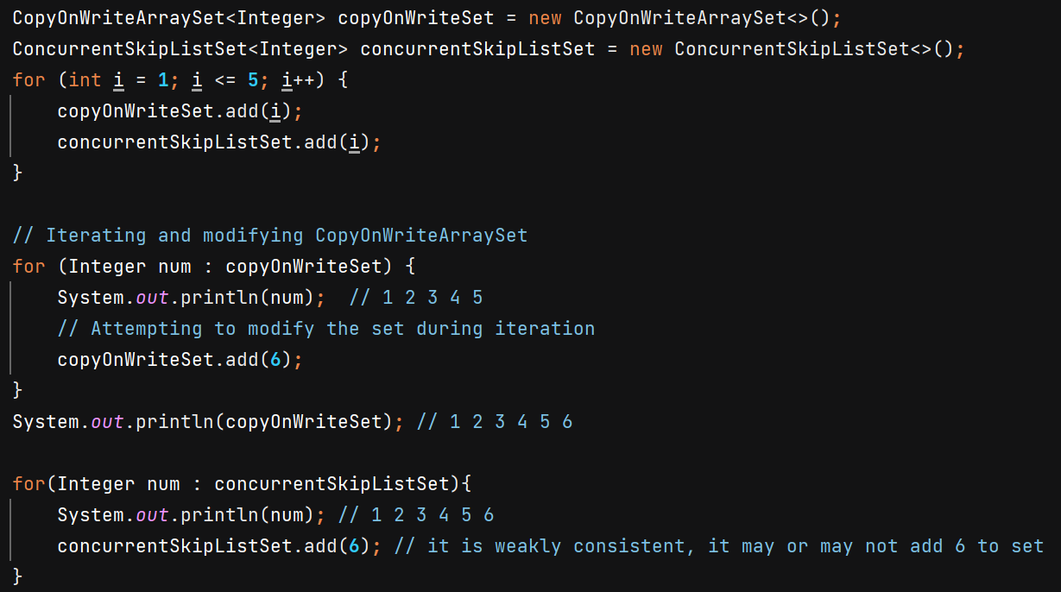

Similarly in case of ConcurrentSkipListMap, ConcurrentHashMap we can add key-value pairs while iterating without getting ConcurrentModificationException. But iterators are weakly consistent so it may or may not see the added entries.

**Queues** – based on FIFO (First in First Out)

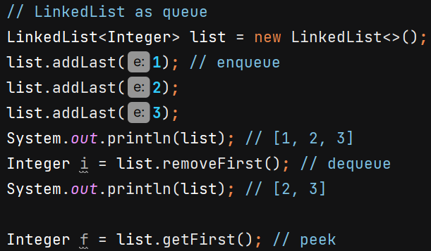

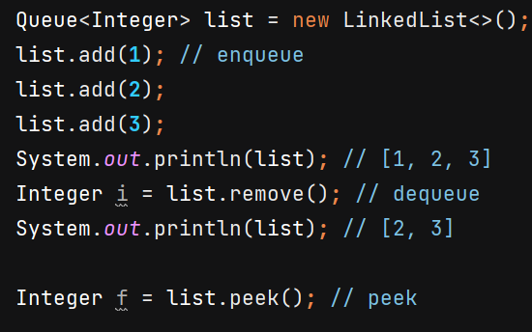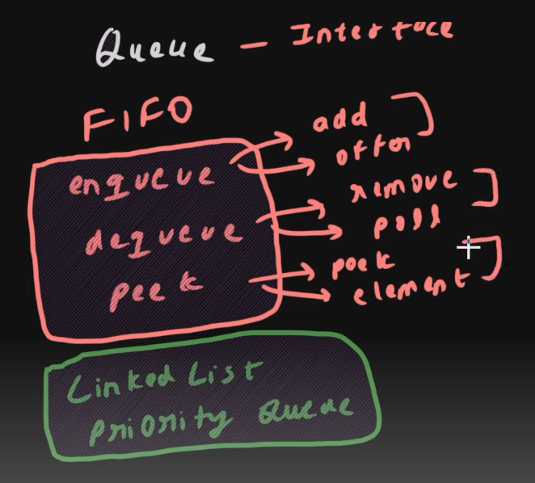

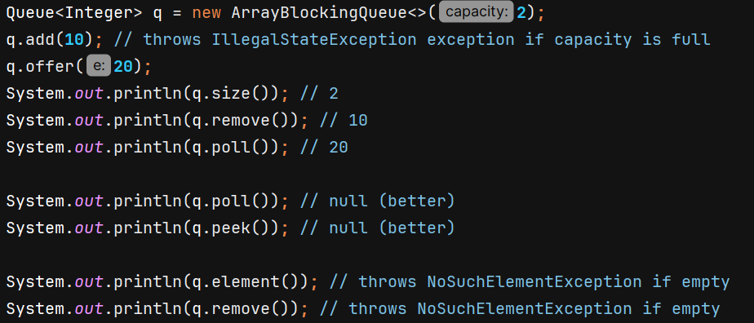

**ArrayBlockingQueue is thread safe.** 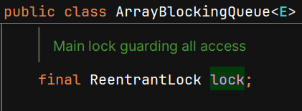 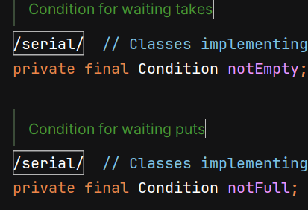

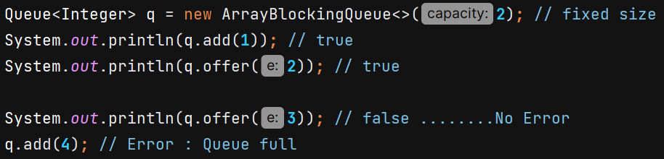

**Priority Queue –**

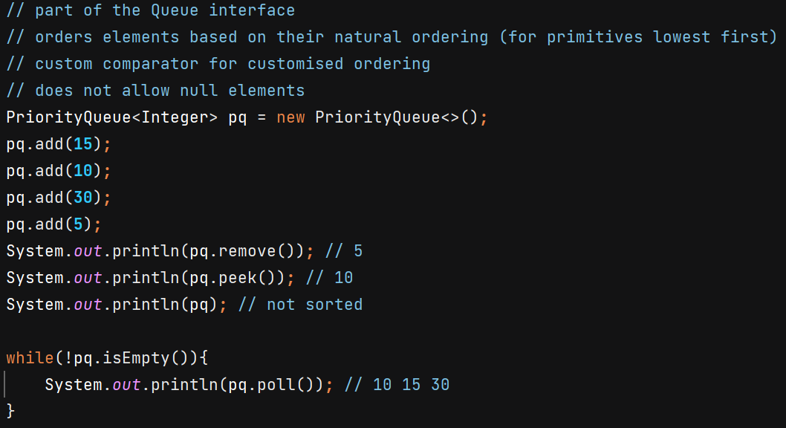

PriorityQueue is implemented as a min-heap by default (for natural ordering)

Min-heap 🡪 binary tree in which parent node is smaller than its child node, having smallest element on root

Time Complexity 🡪 O(1) in retrieve, O(logn) in insertion/deletion



For custom objects –

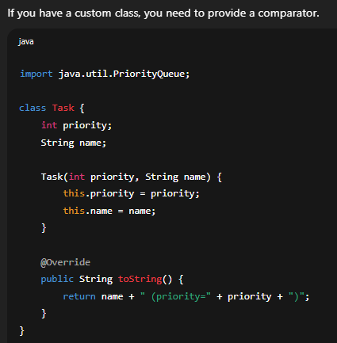

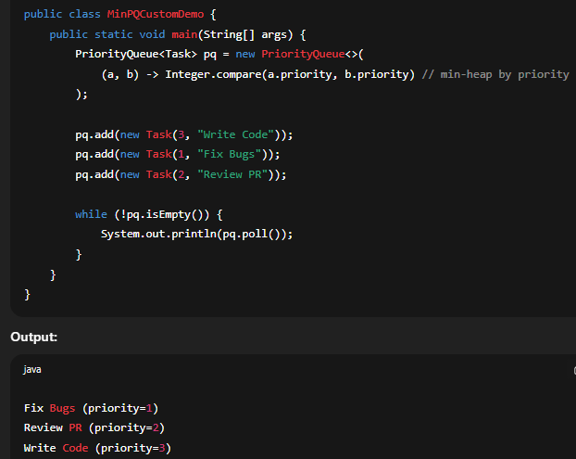

O/P

**Deque –**

* double-ended queue
* allows insertion and removal of elements from both ends
* versatile than regular queues and stacks because they support all the operations of both

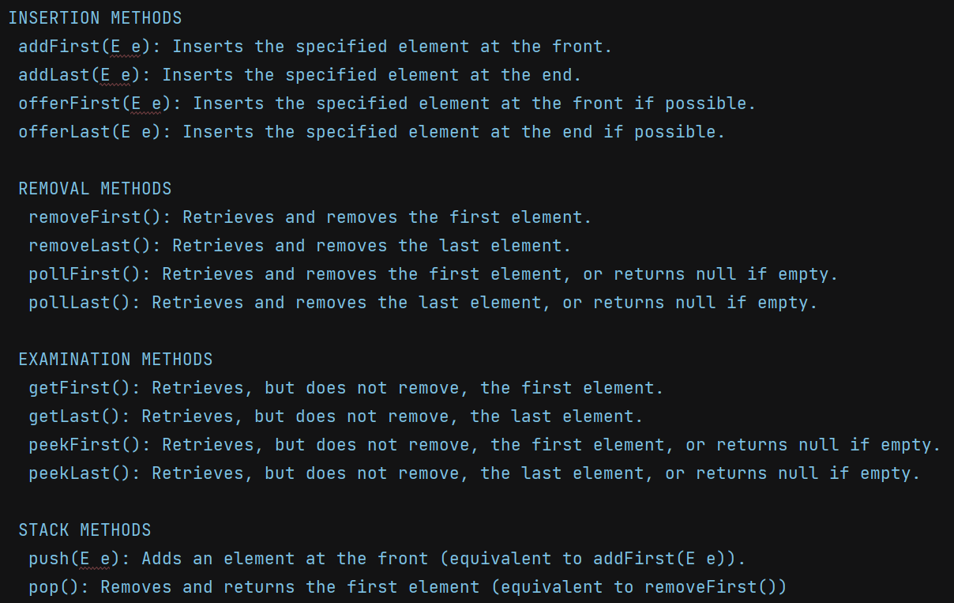

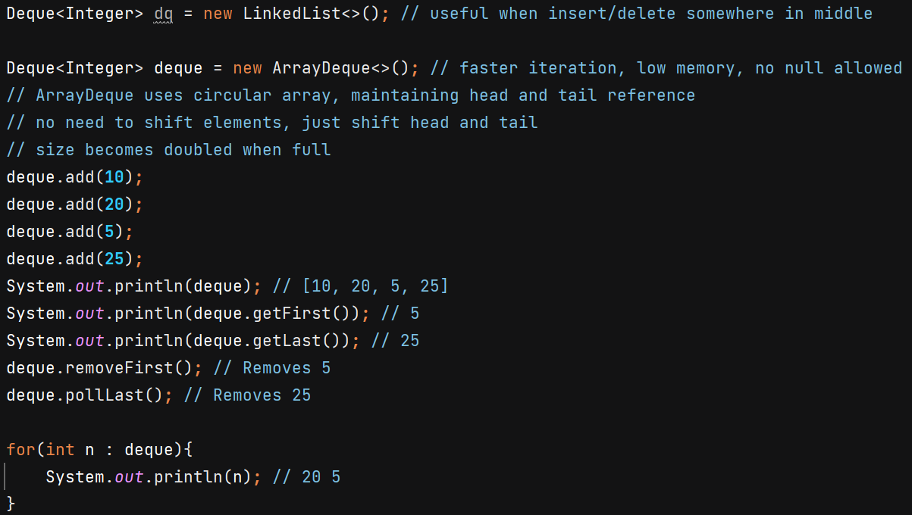

For **BlockingDequeue<E>** interface have **LinkedBlockingDeque<E>** implementation which uses single RentrantLock for enque and deque.

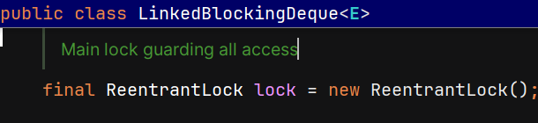

**Blocking Queue**

* Standard queue ---> NOT thread-safe and Does NOT WAIT  
   If empty → poll() returns null  
   If full → add() throws exception / offer() returns false
* Blocking queue is Thread-safe
* **put() -->** Blocks if the queue is full until space becomes available

**take() --> retrieve and removes first element of queue**. Blocks if the queue is empty until an element becomes available

**offer(e, time, unit) -->** Waits for space to become available, up to the specified timeout

* Needed when threads need to coordinate with each other. Ex- Consumer-Producer problem
* Implementations can be **bounded** (fixed size) or **unbounded**.
* Internally uses **locks + condition variables** (notFull, notEmpty) for blocking/unblocking.
* Used by ThreadPoolExecutor to hold submitted tasks.
* Whenever a thread **waits**, it **releases the lock**, otherwise these queues would deadlock.

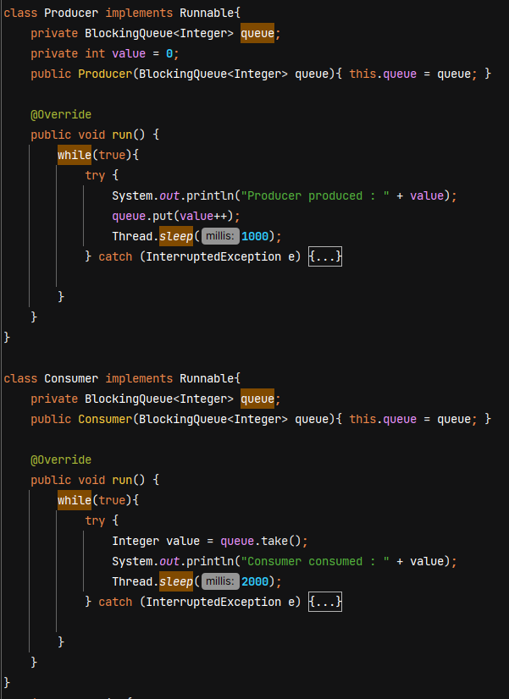

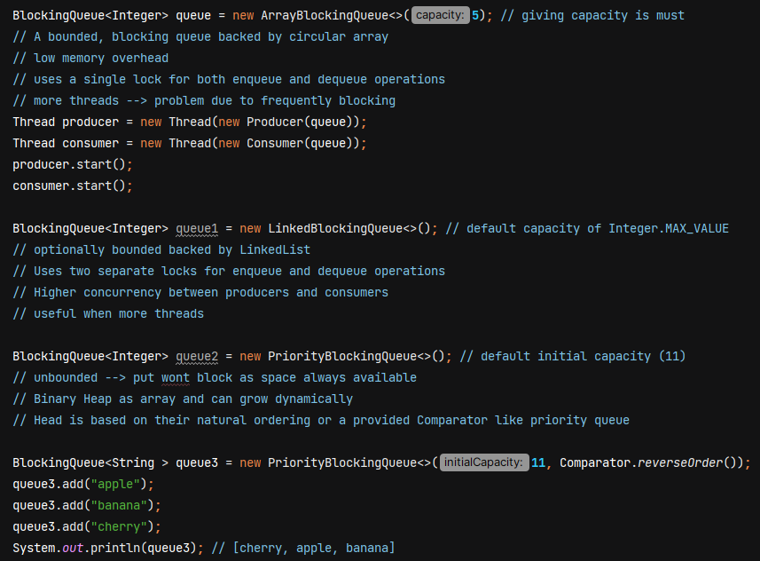

PriorityBlockingQueue uses single lock – 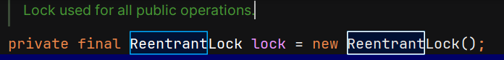LinkedBlockingQueue uses 2 locks - 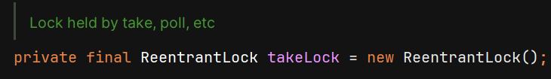 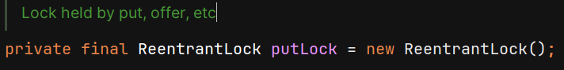

In ArrayBlockingQueue and PriorityBlockingQueue, there is single lock for both take() and put(). 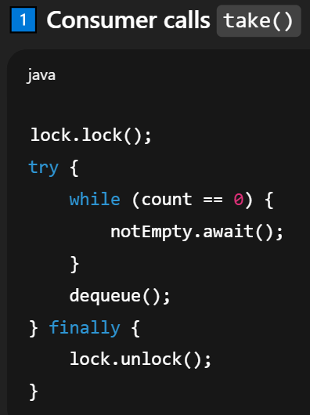 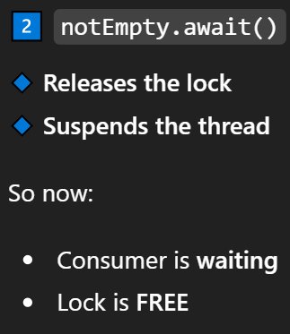 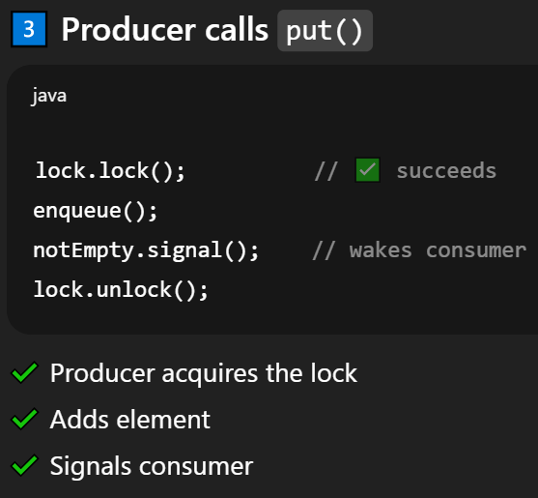 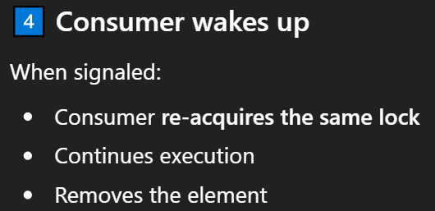

**SynchronousQueue -** each insert operation must wait for a corresponding remove operation by another thread and vice versa. **It cannot store elements**, capacity of at most one element

Implemented using CAS (Compare and swap)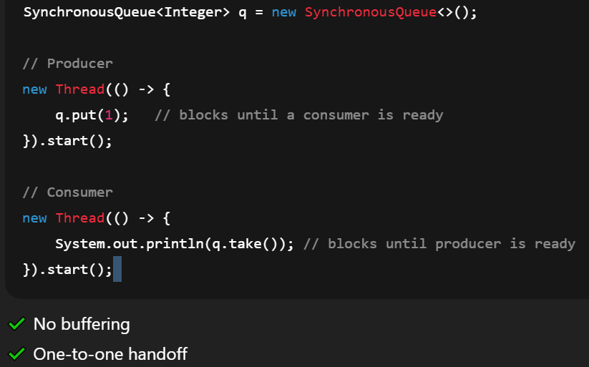

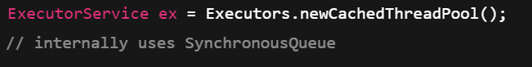 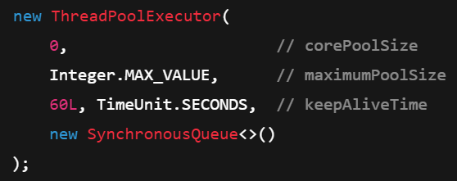

Task is handed directly to a thread. If no idle thread 🡪 new thread is created.

**DelayQueue –**

Thread-safe unbounded blocking queue  
Elements can only be taken from the queue when their delay has expired  
Useful for scheduling tasks to be executed after a certain delay  
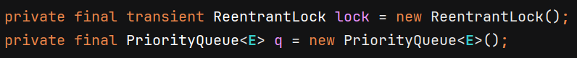

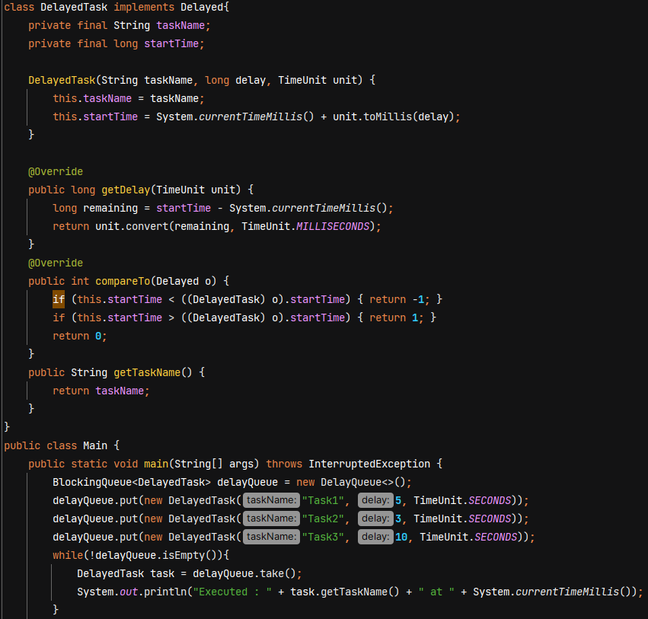

O/P –

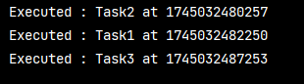

**ConcurrentLinkedQueue –**

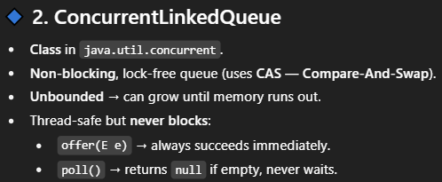

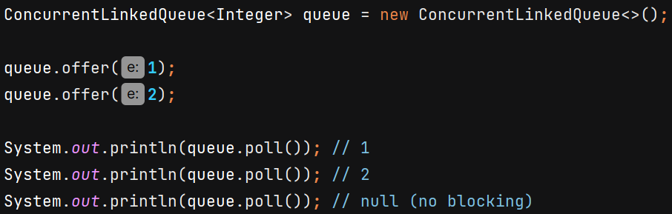

**ConcurrentLinkedDeque –**

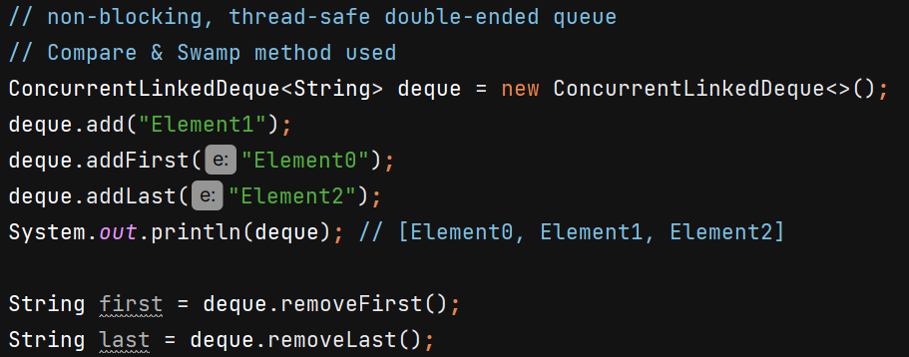

**Collections.synchronizedXxx(...)** – wrap a non-thread-safe collection and return a thread-safe (synchronized) view of it. All public methods of the wrapper are synchronized on a single mutex (the wrapper object itself).

Collections.synchronizedList(), Collections.synchronizedSet(), Collections.synchronizedMap(), Collections.synchronizedSortedSet(), Collections.synchronizedSortedMap().

**Only 1 thread at a time can execute *any* synchronized method on that collection/map**

Must manually synchronize during iteration as it consists of multiple steps – 